**PAMANTASAN NG LUNGSOD NG VALENZUELA**

Tongco St., Maysan Valenzuela City

College of Engineering and Information Technology

Department of Information Technology

**Development and Evaluation of PLVRS: A Room and Equipment Web Application**  **Reservation System for Pamantasan ng Lungsod ng Valenzuela -   
General Services Office**

In Partial Fulfillment of the Course

RESEARCH 1 - Methods of Research in Computing

Arcedas, Mark T.

Garcia, Bryan D.

Martinez, Alexandra Rei P.

Suatengco, Sedrick James J.

JULY 2021

**CHAPTER 1**

**THE PROBLEM AND ITS BACKGROUND**

**Project Context**

A reservation system is used to store, retrieve information, and conduct transactions that are applied in various industries, ranging from air travel, cinemas, and many others. It assists users to reserve a variety of things, ranging from rooms, equipment, clothes, depending on the industry to which that system is being used. It also supports the administrators in managing and storing customer information as well as their reservations. According to a study by Anuar et al. (2013), getting access to the basic information of the location you want to place a reservation to is the ideal situation for any potential customer. According to SiteMinder (2020), having a reservation system provides insight on what and when a user needs something. Through the aid of the online reservation system, it can lessen the work of the secretariat or administrators by simply checking its dashboard instead of manually reviewing the reservations written on paper. In accordance with Molinillo & Japutra (2017), transitioning from traditional practices to modern ones and adopting the use of information technology (IT) is very much seen nowadays, and even in the past years because of the competitive outcome, it produces for the betterment of various industries and enterprises. Not only in hotels, airlines, cinemas, but reservations can be also applicable in schools such as school events and makeup classes. From an article in Ecobook (n.d.), having complete control and visibility to the schools’ resources is vital in providing good management hence, adopting this change will benefit the school, the employees, and the students.

The General Service Office (GSO) of the Pamantasan ng Lungsod ng Valenzuela (PLV) is responsible for the overall management of the campus of the university. Lead by their Building Administrator, Dean Jordan Velasco, and under him is Psalms June Tan, responsible for Facility Management, Sarah Cortez, responsible for Repair and Maintenance Management, and Jonathan Santiago, responsible for Annex Campus Management. Under the jurisdiction of Psalms June Tan is responsible for managing the process of reservations for the buildings that they administer. These facilities include Lecture Rooms, Pre-school Simulation Room, B.A. Simulation Room and the Auditorium can accommodate 50, 120, 50, and 500 attendees respectively. The GSO currently receives approximately 5 reservations on an everyday basis. To create a reservation, students and professors personally go to the office of GSO and must present the letter of approval 3 days before the desired requested date that provides the proof that the said event or activity they are going to do was approved by the necessary higher-ups. There are scenarios where the user requests for a reservation 2 days or less before the desired event which creates difficulties for the GSO to manage the availability of rooms and equipment. Once checked by the GSO, they will be provided with a reservation form that they can use to indicate the facility, the equipment they need, as well as the schedule of the reservation. The user will have a short interview with the person responsible for the reservation to validate the person, to know if any props are going to be used, and to discuss the dos and don’ts to a borrowed room and equipment. Afterward, the user must photocopy the approved reservation signed by the GSO and for both sides to have a copy of the reservation. To borrow equipment, the user must present their ID for verification. Booking of equipment is optional if the user needs it. Therefore, allowing a room to be reserved even if there is no equipment borrowed is allowed, but borrowing only equipment is prohibited. The rooms mentioned above have an equipment categorization whereas some of those are not allowed to borrow certain equipment. There is allocated 1 projector per facilities such as the Lecture Rooms and Simulation Rooms. A built-in projector and a speaker for the Auditorium. Projector screens, mobile speakers, and microphones are not available to borrow for Lecture Rooms. While monoblock chairs are not available to borrow when requesting a reservation for Auditorium and Lecture Rooms. The GSO will then check if everything they need is available at the time they want. The process runs on a first come first serve basis, so if someone wants to reserve but the slot was already filled by another reservation, they have no choice but to reschedule their reservation. The approval of reservation usually takes 1-day depending on the availability and presence of the person in charge in their office. If the user requests a room that is not under the jurisdiction of GSO, he/she will be advised to go to the Registrar Office. The user can cancel their reservation a minimum of 1 day before the reserved date by personally going to the GSO. But there are scenarios wherein the requestor wants to cancel their reservation on the same day which provides difficulties for the GSO. They store the reservation forms together with the letter of approvals in a cabinet inside their office. Reservations are listed in a calendar drawn on a whiteboard that contains the general details of the reservation if there is one.

The current process of reservation is that students/professors must personally meet with the person in charge. It does not guarantee that the available time of both sides will always coincide and there can be instances where they will not meet whenever they want to. The GSO also manually partakes in most of the processes involved, from checking the availability of room and equipment to giving out to users the reservation form, which can easily be seen as a tedious process. Additionally, the mode of storage that they currently have is prone to be damaged or degraded easily, which could result in the loss of most records in the long term, and it also takes manpower to look through the records that they currently have in case they need to look for a specific reservation.

Considering the said problems, the proponents have decided to develop and evaluate Pamantasan ng Lungsod ng Valenzuela Reservation System (PLVRS), a web application room and equipment reservation system to help the GSO in improving the current reservation process.

**Problem Statement**

How will the proponents develop and evaluate PLVRS, a web application reservation system to help the GSO in improving the current reservation process and providing an inventory management system? Specifically, the proponents aim to answer the following questions:

1. How to develop and evaluate a web application reservation system for the:
   1. Users that is capable of:
      1. Registering accounts
      2. Requesting reservation as long as they are verified
      3. Rescheduling and/or cancel their reservation
      4. Receiving updates on their reservation
      5. Recording all reservations made by the user
   2. Administrator that is capable of:
      1. Creating accounts for administrators
      2. Approving or rejecting user registrations
      3. Modifying user information
      4. Approving or declining reservation
      5. Modifying reservation details
      6. Recording all reservations made by all users
      7. Adding, removing, and modifying room and equipment details
      8. Contacting users
      9. Generating a printable report of a reservation
   3. Web application that is capable of:
      1. Displaying a calendar of accepted reservations
      2. Displaying rooms and equipment available for reservation
      3. Displaying the status of the requested reservation
      4. Displaying policies of the reservation process
      5. Notifying the users and administrator via PLVRS and email
      6. Generating a monitoring form for every reservation
2. How to develop and evaluate an automated process that is capable of:
   1. Updating reservations that are over as done
   2. Declining reservations that coincide with prior reservations
3. How to develop a database that is capable of storing the following information:
   1. User information
   2. User reservation information
   3. Administrator information
   4. Room and equipment information
4. What is the level of conformity of the PLVRS with regards to the ISO/IEC 25010:2011, System and Software Quality Requirements and Evaluation standards?
   1. Functionality
   2. Reliability
   3. Usability
   4. Efficiency
   5. Maintainability
   6. Portability
   7. Security

**Purpose and Description**

The PLVRS will serve as an aid to eliminate the need for personal meetings between the user and the GSO to request reservations as well as the obligation of the GSO to manually check the availability of room and equipment for each reservation and instead, let the system automatically decide whether requested room and equipment are available. It also provides a more secure way for the GSO to store information of the records and helps the GSO manage their inventory easier. The function and capabilities of the system are as follows:

1. Users and Administrators can view the website in web browsers.
2. Users and Administrators can view approved reservations.
3. Users can register accounts.
4. Users can log in to the website.
5. Verified users can request reservations.
6. Verified users can cancel/reschedule their reservations.
7. Administrators can create additional administrator accounts.
8. Administrators can view current and past reservations.
9. Administrators can add, remove or modify room and equipment available for reservation.
10. Administrators can modify user details.
11. Administrators can modify reservations.
12. Administrators can contact users that created a reservation.
13. Administrators can record their reports using the maintenance form.
14. The system notifies users about their registration and reservation via email.
15. The system notifies administrators about reservations being made.
16. The system automatically generates a report for every approved reservation.
17. The system stores user and administrator information
18. The system stores user reservations.
19. The system stores room and equipment information
20. The system generates a monitoring sheet for every reservation

Stating the functions and capabilities of the PLVRS, the proponents identified that the system will be an essential tool nowadays for providing convenience to the users in making a reservation, and to the administrators in managing the room and equipment of the university. Thus, this capstone project will benefit the following:

Pamantasan ng Lungsod ng Valenzuela – The PLV will directly benefit since the system is reducing the burden for their employees, creating more opportunities to spend time more efficiently.

General services office – The GSO will be able to use the system to efficiently manage the reservations of room and equipment under their name, as well as automating the reservation process completely.

Students – Students will be able to reserve rooms and equipment needed for their own studying needs while being hassle-free from the multiple processes involved in the current method.

Professors – Professors will be able to reserve room and equipment needed for teaching, especially when a specialized discussion is required that needs them to have room and borrow equipment from the school. It also automates their approvals when students require them, making it a lot more efficient and less of a hassle for both the student and the professor.

Future researchers - Future researchers will be able to use our research as a reference and can even provide improvements and enhancements towards the system itself.

The Proponents – As senior students of PLV, the proponents will be able to experience the improvements of the system developed for a room and/or equipment reservation under GSO, as well as being able to experience developing and designing PLVRS itself.

Users will be able to request reservations conveniently when the system will be developed. However, they are required to follow the new process that the system will provide. They will also need to pay attention to the updates with regards to their reservation, and the GSO themselves will need to update the status of rooms and equipment after every reservation.

**Objective of the Project**

To develop and evaluate PLVRS, a web application room and equipment reservation system to help the GSO in improving the current reservation process and providing an inventory management system. In alignment with the main objective, the proponents aim the following:

1. To develop and evaluate a web application reservation system for the:
   1. Users that is capable of:
      1. Registering accounts
      2. Requesting reservation as long as they are verified
      3. Rescheduling and/or cancel their reservation
      4. Receiving updates on their reservation
      5. Recording all reservations made by the user
   2. Administrator that is capable of:
      1. Creating accounts for administrators
      2. Approving or rejecting user registrations
      3. Modifying user information
      4. Approving or declining reservation
      5. Modifying reservation details
      6. Recording all reservations made by all users
      7. Adding, removing, and modifying room and equipment details
      8. Contacting users
      9. Generating a printable report of a reservation
   3. Web application that is capable of:
      1. Displaying a calendar of accepted reservations
      2. Displaying rooms and equipment available for reservation
      3. Displaying the status of the requested reservation
      4. Displaying policies of the reservation process
      5. Notifying the users and administrator via PLVRS and email
      6. Generating a monitoring form for every reservation
2. To develop and evaluate an automated process that is capable of:
   1. Updating reservations that are over as done
   2. Declining reservations that coincide with prior reservations
3. To develop a database that is capable of storing the following information:
   1. User information
   2. User reservation information
   3. Administrator information
   4. Room and equipment information
4. Conform to the ISO 9126-1, System and Software Quality Requirements and Evaluation standards
   1. Functionality
   2. Reliability
   3. Usability
   4. Efficiency
   5. Maintainability
   6. Portability

**Scope and Limitation**

PLVRS is a Computer Reservation System solely developed for the General services office of the Pamantasan ng Lungsod ng Valenzuela. As a web application, it can be accessed via web browsers such as Google Chrome version 4.022324, Mozilla Firefox version 5 to recent, and the like. It is recommended to use the latest and official build of Chrome, Version 88.0.4324.190 or any matching builds of other browsers. PLVRS is a web application, therefore it will be able to run on devices that support web browsers, which includes, but is not limited to, personal computers, iPhones, iPods, MacBook, smartphones. The system aims to provide users the ability to request reservations for room and equipment usage that is under the jurisdiction of the GSO.

Upon opening the web application, users should be able to see a calendar containing the current month, as well as reservations for that month, if there are any. They are required to register an account before being able to request a reservation. To register, users will need to present their name, email, contact number, and a valid ID. The GSO will only accommodate the registration of PLV students and PLV professors, hence users are required to present their valid PLV student ID or PLV faculty ID. All registrations will personally be reviewed and verified by the GSO and only verified users can request reservations. They can request reservations by clicking on a date and proceeding to press the create reservation button or by clicking their profile icon and selecting the “create a reservation” option. The system will then prompt the user to fill out the details concerning the reservation together with their attachment of the letter of approval for the event they are going to perform. The system will then put the reservation in a pending status, and will then notify the administrators of the pending reservation. Afterward, the Administrators will check if the letter of approval was valid and signed properly by the necessary authorities. If everything is in order, the GSO will then approve the reservation and the system will automatically accept the reservation and reflect it on the calendar. The system runs on a first come first serve basis, therefore reservations that coincide with prior reservations will automatically be declined regardless of who or what the event is for. Each reservation would be labeled by a control number as their identifier. Reservations must be requested a minimum of 3 days before the day of the event itself. Cancellations must be requested at least 1 day before the reservation date. In case of rescheduling, users can request a reschedule 1 day before the reservation, and they have 3 days to upload the newly signed letter of approval indicating the change of date of the reservation. If the allotted 3 days have passed and the user has not submitted the requirements needed, the reservation will be removed and the users must create a new reservation request from the start. Administrators can generate a printable report of the accepted reservation. Administrators will need to fill up a maintenance form after every reservation which will automatically be generated with its contents depending on the room and equipment borrowed for that reservation. The monitoring sheet is used to record the status of the equipment borrowed after the reservation so that the system can automatically update the status after every reservation. In case of broken equipment, users will be required to submit a detailed report on what happened.

PLVRS has no stand-alone desktop/mobile application, and since it is accessed via web browsers, an internet connection will also be a requirement for its usage. Non-registered/verified users will only be able to view reservations. Any issues with a human error such as typographical mistakes or grammatical errors are outside the influence of the system. The built-in management system for room and equipment would not focus as a full inventory management system, but would instead be utilized so that administrators can display the quantity and its availability as well as being able to be modified depending on the result of the monitoring sheets after every reservation and on their judgment.

**Definition of Terms**

Cascading Style Sheets (CSS) – is used to create a pleasing design of PLVRS.

Database – Stores the information of the reservations made as well as any information stored by the website, both from the admin side and the user side.

Extensible Markup Language (XML) – Text-based markup language that will be used to move and transfer data for the PLVRS.

General services office (GSO) – Handles the management, cleanliness, and orderliness of the building assigned to them, and in this case, the PLV campus.

Hypertext Markup Language (HTML) –language that uses tags to create the front end of the PLVRS.

Javascript – Is used to define the backend of the PLVRS.

MySQL – a language used to manage the database which will store the information of users, administrators, and reservations of the PLVRS.

PHP – a server script that communicates with the server to exchange data with PLVRS.

PLVRS – Maintain the transaction and reservation of GSO.

Users – Anyone who has the ability and credentials to make a reservation.

Administrators – users with special privileges. Can only be given out by the GSO

Website - A group of web pages that makes up the PLVRS.

Web browsers – An application used to access the website that holds PLVRS.

**Conceptual Framework**

The conceptual framework represents the overall requirements needed to fully develop a web application room and equipment reservation system for the Pamantasan ng Lungsod ng Valenzuela – General Services Office.

Figure 1

Input-Process-Output Diagram of the Capstone Project PLVRS

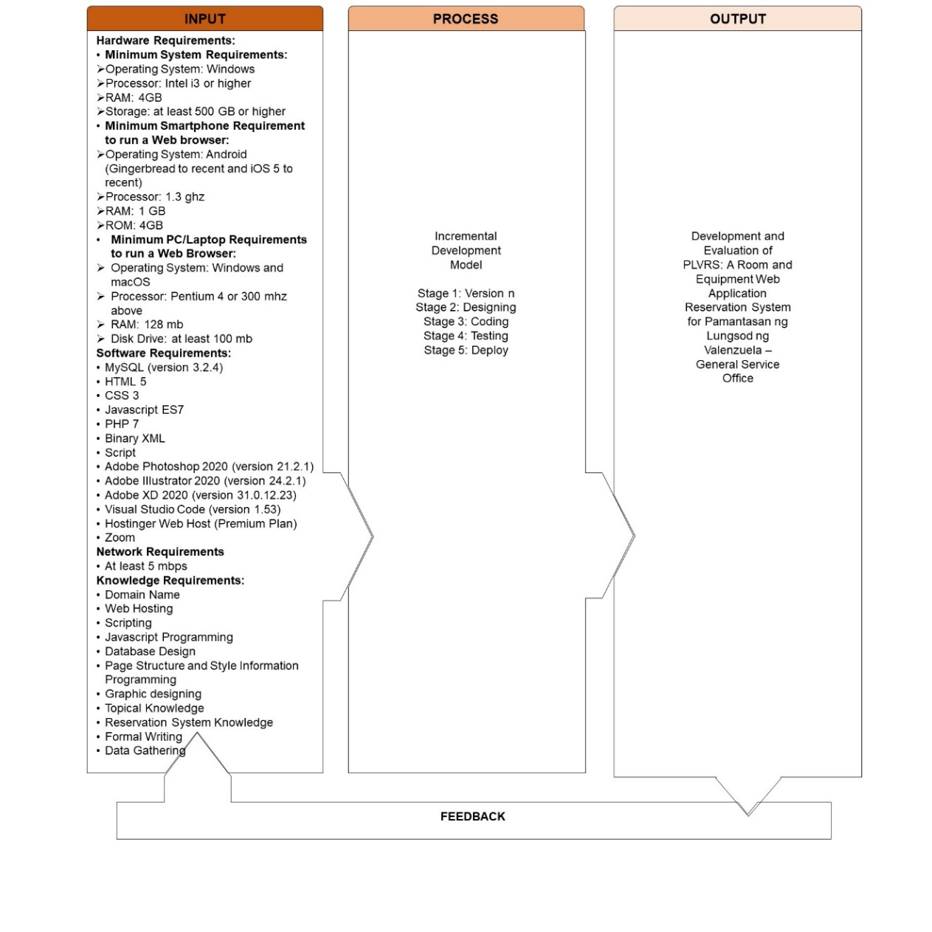

The Incremental Development Model consists of the step-by-step process of requirements specifications, designing, coding, and testing where it provides a series of multiple versions with a different requirement and module. After every process, a different version of the system is made with concerns to the development requirements. The proponents have decided to use this model because it will let the stakeholder know the current development of the system which will be always open for revisions and recommendations that will also grant room for improvements. As a result of its flexibility in designing, coding, and testing, the incremental development model is commonly used to effectively develop software for businesses to show to the users or stakeholders the progress of the system. Furthermore, this kind of development will also be applicable for an established university that will serve hundreds of users and possess the possibility to be used in the future, hence delivery of satisfaction for every version of the system must be obtained.

In acquiring the requirements and specification of the PLVRS, data-gathering through Zoom, a video and audio-conferencing application that can record (Antonelli, 2020), with a stable internet connection will be done together with the stakeholder to know the requirements and certain desires for the proposed system. After data gathering, the proponents will then break down the requirements into smaller parts, thus starting the process of making the first version of the system with its specified requirements. Creating each version of the system will take place by using computers with an Intel i3 or higher processor, at least 4GB RAM, and 500 GB of storage by using Windows Operating System (OS). Testing each version of the system developed will be done by the proponent’s device and the user’s device such as a smartphone with an OS of Android and iOS, and a different Personal Computer (PC)/Laptop with Windows and macOS. Knowledge requirements will serve as the foundation and as basic tools to make it possible to fully develop the proposed system, such as the programming languages, database design, graphic designing, web hosting, knowledge with the capstone project, knowledge of the process of reservation that happens in various industries, and formal content writing.

Drafting the user interface will require the use of Adobe Photoshop 2020 (version 21.2.1), Adobe Illustrator 2020 (version 24.2.1), and Adobe XD 2020 (version 31.0.12.23) for prototyping while creating the web pages will require the use of Hypertext Markup Language 5 (HTML), Cascading Style Sheets 3 (CSS) to design the system web pages, JavaScript ES7 to create the backend of the web application, XML 1.1 to handle data formatting and PHP 7 in conjunction with MySQL (version 3.2.4) will be used to handle database related transactions and processed. Visual Studio Code (version 1.53) will be used as the main programming software in coding the system. The PLVRS will be hosted by a premium plan from Hostinger where it has a weekly back-up, 99.9% uptime guarantee, Cloudflare protected name servers, unlimited databases, unlimited bandwidth, free SSL, free domain, etc. Aside from the webserver as an online backup, the data that will be used in the web application will also have its local backup. The use of the software requirements and knowledge requirements for each version of the development is dependent on the requirements specified in each version.

Before the deployment of the first version of the system to the stakeholder, the system will undergo a testing phase to be observed for possible errors and issues and will promptly be fixed, and only then will the first version of the system be deployed to the stakeholder to be reviewed. The first version of the system that was reviewed will automatically be revised and continuously added to the following version of the system to have incremental progress until the requirements and specifications of the stakeholder are fully met and the PLVRS is fully developed.

**CHAPTER 2**

**REVIEW OF RELATED LITERATURE AND SYSTEMS**

**Technical Background**

A Central Reservation System or Computer Reservation System (CRS) is a web-based system used by travel agencies and travel management such as hotels, airlines, car rentals, and others to conduct transactions. CRS is the general term used to describe reservation systems across various industries and is specialized in eliminating the distance needed for a consumer and a company to transact, making transactions a lot easier to perform.

A Website is a group of web pages that can be linked under a single domain name. In simple terms, it is comparable to how a book is, but instead of being able to feel and see that there are multiple pages, a website often shows only one on the screen, the one that you picked to visit itself. Tools to open websites are called Web Browsers which is the one responsible for retrieving the specific content a user asks from a web server and reflects that on the device of the user.

Programming languages are tools used to produce different types of outputs through the use of instructions. An integrated development environment is software that allows computer programmers to have their personal environment when developing applications.

A markup language is a system that uses tags to display text, wherein tags are the “format” of the text itself. It is human-readable, unlike programming languages, which makes it easier to comprehend most of the time.

**Related Literature**

A Web application and a website can be described as something both different and similar from each other. From an article by Belsky (2017), 3 points differ one from the other is "Interactivity, Integration, and Authentication". A web application is more focused on functioning by having an interaction with its users, being similar to how a mobile application is, while websites can simply be described as static and focus more on a one-sided presentation. Another article from Essential Designs (2019) also described websites as "One-way informational feeds" and described web applications as "websites with functionality and interactive elements".

An article from Parker Software (2019) compared how web applications are much more accessible than Desktop applications due to their much lax requirements in terms of hardware, accessibility, and updates. Additionally, an article by Stevens (2018) compared web applications, this time to mobile applications. The article described the comparison between mobile applications and web applications similar to how the previous article described desktop applications vs web applications, with web apps not requiring installations and much easier to maintain compared to mobile apps. As stated by Summerfield (n.d) in his article, a mobile website has an advantage over mobile applications, specifically, it is “compatibility, cost-effectiveness, and broader accessibility”. The author gives insight on the inherent advantages that a Mobile website has over mobile applications, as well as the conditions that are needed for one to even consider creating either a mobile website or application. Additionally, mobile websites were indicated to not be limited to a single mobile device, unlike mobile applications where separate versions are needed to be developed to be usable in other devices. Besides, mobile websites are not limited to being accessed by smartphones, since the only requirement is for a device to be able to access web browsers, any device that can open web browsers can use websites.

It was stated in an article by Velocity Consultancy (2018) that websites are a way to communicate with users, promoting their brands to drive their growth. They also listed 10 elements a website should have, namely “User-Friendly Website Navigation, Web Design, and Layout, Responsive Design, Content Writing, Call to Action, Testimonials, Opt-in offer, Story Telling, FAQs Section, and Contact Information. However, creating websites and web application is not only limited in its content and design, especially when the website asks for the personal information of its users. As stated by the LRS Web Solutions (2018) in their blog post, adopting web applications in businesses can help them interact more with their customers and can reach out to an abundance of clients. Using this kind of platform will enable businesses to grow but because of the confidential and sensitive information that is brought online, securing the web application itself should be considered and developers are obliged to protect and secure that information. One of the most notable best practices in securing web applications is being proactive in the possible scenarios that may arise in the future. The plans and techniques in mitigating security threats should always be ahead of the current threats as of today because alongside a robust system is an evolution of security threats. Other best practices include maintaining the security during the development, requiring injection and input validation which will ensure parameters, encrypt data, usage of exception management, apply authentication, role management, and access control, proper measures for hosting services, avoiding security misconfigurations, implementing Hypertext Transfer Protocol Secure (HTTPS), including auditing and logging, and use rigorous quality assurance and testing. As stated above, using a web host is also a part of securing a web application. According to a blog post by Domantas (2020), web hosting is an online service that helps developers to publicize the site or web application on the Internet. The author also described that at the point of purchasing a web hosting service, developers will lease server space that best fits their requirements which would store all the essential data that the system needs for it to work appropriately. Aside from an added security, according to a blog post by Vents (2019), it is also important for a website to have fast loading times for the benefit of the users since “40% of visitors leave a website if it fails to load in as little as 3 seconds”. Not only speed but the author also emphasized the location on which the server should be hosted since a website hosted in the same country as the server would have a faster loading speed compared to a website hosted in a different country. The proponents aim to adopt these elements and practices to PLVRS to be able to show a proper and secure web application system. The proponents also aim to show to the public the improvements that the PLVRS can provide for the PLV, specifically on the system of reservation used by the GSO.

An article by ColorWhistle (2020) describes Computer Reservation Systems (CRS) as a "web-based software used to retrieve and conduct transactions". The article described the objective of CRS as a way to "eliminate the physical and geographical distance between mediators and consumers". Originally designed for airlines, CRS has now extended its use towards travel agencies and Global Distribution Systems which widened the coverage of the system and could produce and transfer greater information to different industries and corporations. According to Travelopro (2019), CRS plays a vital role and revolutionizes the entire travel industry. It is a system that is used to “store and retrieve” information, which industries use to conduct transactions with their customers. The article also stated that it serves as the backbone for the business of travel agencies.

As stated in the article by Steeves (2020), booking systems can help the owners keep track of every reservation and detail of which products make them the most money. This feature is also applicable to the reservation system wherein the system will keep a record of what rooms and equipment are frequently used so that they can monitor the conditions of every room and equipment that is borrowed and perform maintenance if needed. Also, keeping track of records is important, and according to Tyrocity (2019), gathering required information with speed and accuracy is possible with the use of records, it is important because the records are the reason why an office can run smoothly and effectively. The proponents aim to adopt those characteristics and apply them to PLVRS to aid the GSO to keep track of their records and increase the productivity efficiency inside their office so that they can run it smoothly. From an article by DAS Solutions (2020), the 4 benefits that the proponents want to include in their system are, “Save time and cut costs, automate booking process, reduce error, and increase customer satisfaction”. The proponents aim to adopt these benefits to the office of the GSO on their reservation system.

Henry (2018) studied online booking systems and their effects on the current system. His research led to the conclusion, as stated in his study, that the “development of online booking systems constituted a total revolution” (p.9). According to Powell (2018), most people prefer having an online booking reservation as it makes the process more convenient. They can make a reservation wherever they are, whenever they want with just a few clicks on what they want to reserve. Hotels have great opportunities because their offers are visible on the web, which gives customers much greater access and visibility towards the offers of a hotel. However, he also stated that there are issues with the reservation if hotels use independent sites to host their reservation services, which will not be a problem in the proponent’s case due to PLVRS being custom-made for the school itself. According to Gungon (2021), usage of the internet and technology is inseparable to any person and applies not only in businesses but also in other sectors. Therefore, it is very much conceivable that an online reservation system can also take place in schools. Compared to business industries where their target is to increase their sales, the goal of schools’ is to mitigate the long process of making room reservations. Additionally, according to Ecobook (n.d.), schools have “unique challenges” when it comes to the management of the schools’ rooms and resources due to the rules that schools have compared to businesses. Nevertheless, theoretically foreseeing that most of the students and professor in the university have a device and sufficient amount of internet data that can access a website because of the free Wireless Fidelity (Wi-Fi) in PLV (DICT, 2020), developing a room reservation web application system with complete functionality that the school requires will help the school itself in managing reservations.

**Related Studies / Systems**

The University of Washington’s College of Education Technology Center (n.d.) also has its reservation system under its website, with detailed policies and rooms possible for reservation. Unfortunately, due to access to the reservation itself requiring login information, the proponents were not able to access the system itself, however, the policies for their reservation system can be seen publicly. The proponents do agree with the general idea of their reservation system, mostly prioritizing reservations made for academic purposes. However, the proponents do not agree with them limiting the users available to reserve directly to professors. Students, according to them, need to contact a respective authority before being able to apply for a reservation, unlike the vision of proponents where both students and professors are considered as users, and can both apply for reservations following the same procedures.

Figure 2

Room Reservation for Meeting Rooms

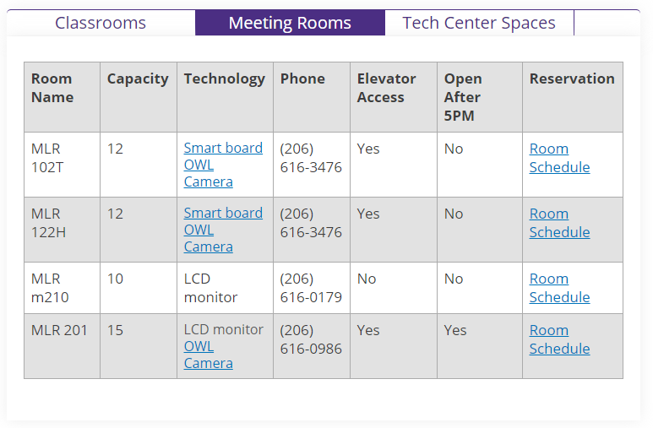

Figure 3

Room reservation for Tech Center Spaces

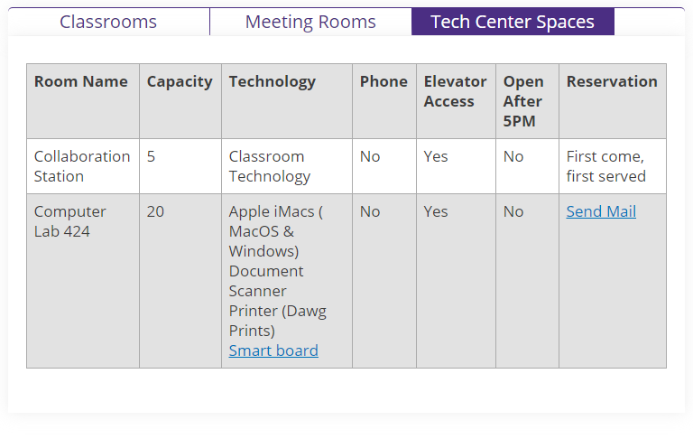

Figure 4

Room previews and equipment included

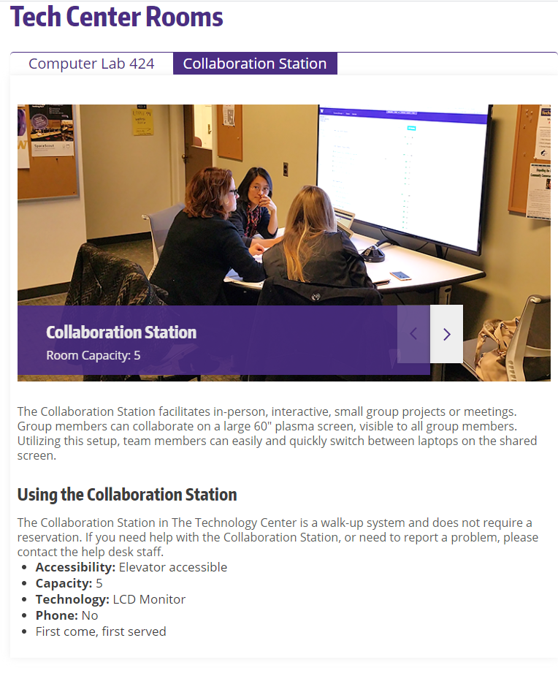

From the study of Atkinson & Lee (2018), they stated that the creation of “study rooms” in libraries could help students in collaborative work, as well as prevent the issue of first come first serve basis hoarding. The idea presented is similar but different from what the proponents had, in that the study proposes to “create” while the proponents propose to “use” rooms. Not to mention the issue of problems that are needed when creating rooms, the study also had problems with the lack of staff to help manage the rooms, whereas the proponents’ locale could mitigate such needs due to the existence of surveillance cameras across each floor of each building.

A study by William & Micheal (2018) implemented and enhanced the current file cabinet system of the Grand Ville Hotel; from the slow process of the hotel, they made a system whose capability is to lessen the workload and improve the overall management of the reservations of the hotel. The features of the system include searching rooms and sending an email to their users upon registration. To make the process of reservation organized, they required the personal information of users such as full name, phone number, address, and email address. The customer has the freedom to choose a specific room to be reserved. The proponents want to adopt this feature to the PLVRS to prevent the registration of multiple accounts and to help notify users about updates on their reservation using the details they gave.

From the Help center of Facebook (n.d.) about confirming email or mobile phone number, it stated that to confirm a user’s email, click or tap the link that the user has received in their email when they created an account. The proponents aim to utilize the said feature in the reservation system.

Figure 5

Facebook Email Verification

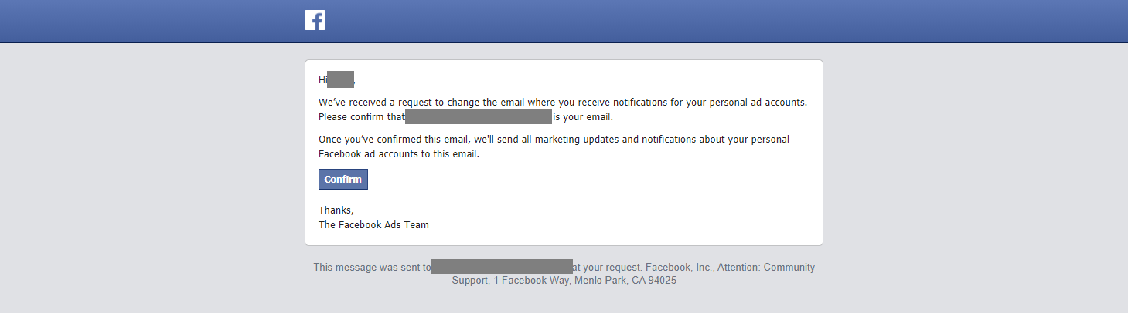

Conforming to Hotel Reservation System for Hotel Selenna (2020), they are implementing an improvement for the current reservation of Hotel Selena, specifically in the way that it would produce less error, take less manual effort, and make it much easier for the users to book reservations. The proponents aim to follow the same path, although in a different direction since the proponents aim to develop and evaluate a reservation system for a school.

There are multiple systems that different industries use as their Central Reservation System, and one of these is the Yarooms. Yarooms is a cloud-based room reservation developed for a variety of businesses. The system itself is accessible on a desktop, tablet, and phone to book rooms for meetings, schedule appointments, provide real-time availability of rooms, monitor upcoming meetings, and gather data from the users. The users can book a room via a web browser, mobile phone, tablet, or thru email via Microsoft Outlook. It provides real-time availability of rooms, ensuring that users can identify which rooms are used. The software also provides a calendar that monitors the schedules of booked rooms, as well as a map that displays the overall locations of rooms in each office. (Yarooms, 2020). PLVRS is similar to Yarooms since it also has the proposed system's functionalities and capabilities. However, PLVRS will exclusively be for PLV and only the administrators can add rooms if the school itself expands its buildings and facilities. Indeed, offices are quite involved in terms of innovation and modernization, but universities and schools also need such improvements.

Figure 6

Desktop Calendar User-Interface of Yarooms

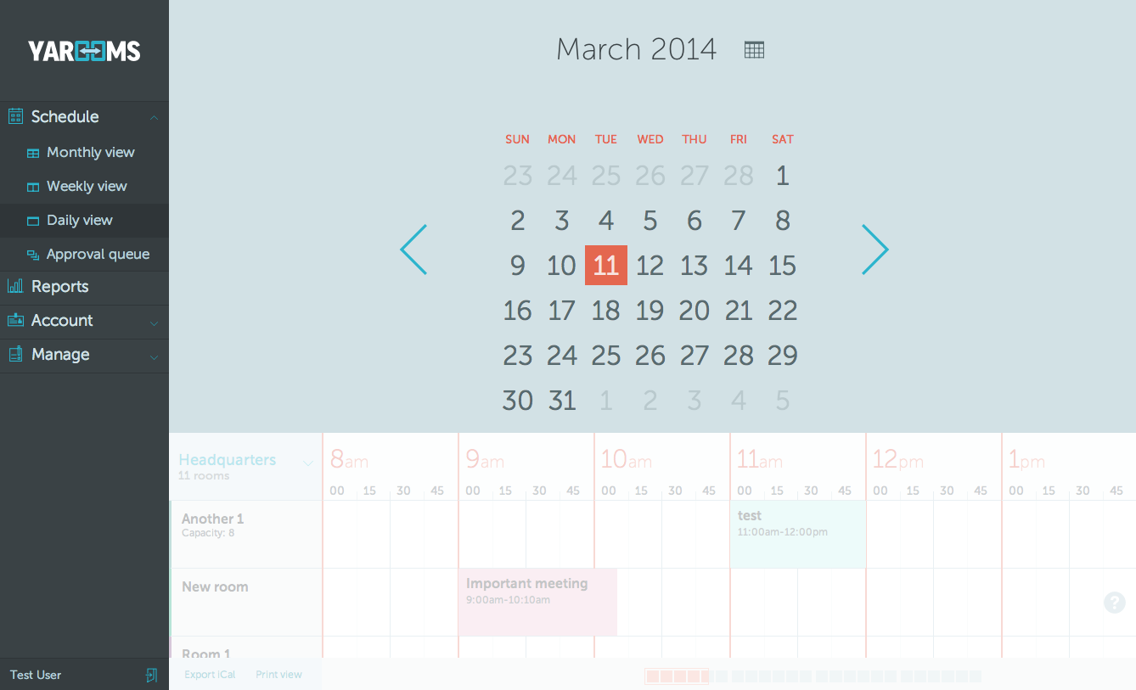

Figure 7

Desktop Daily Schedule User-Interface of Yarooms

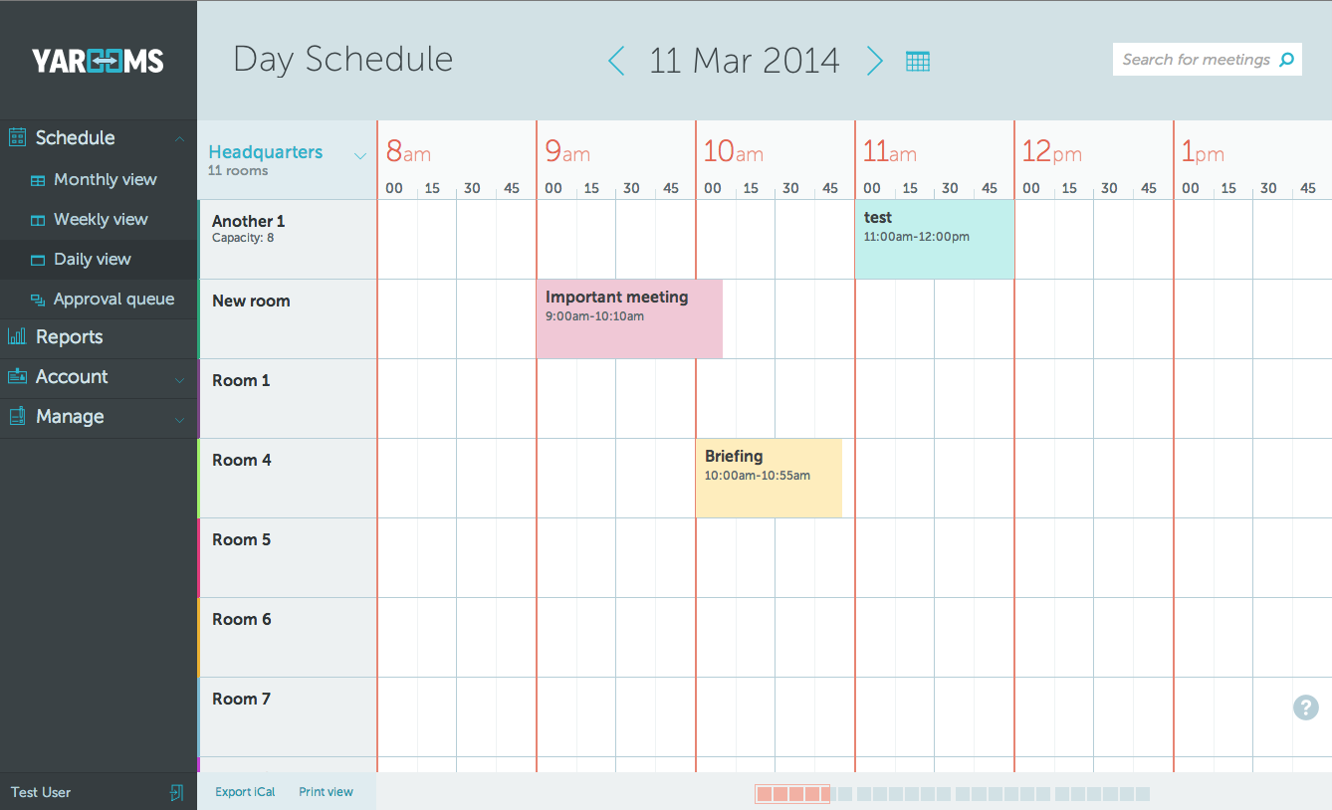

Figure 8

Availability Preview User-Interface of Yarooms

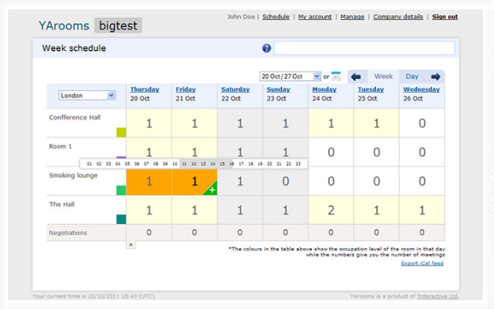

Figure 9

Instant Booking User-Interface of Yarooms

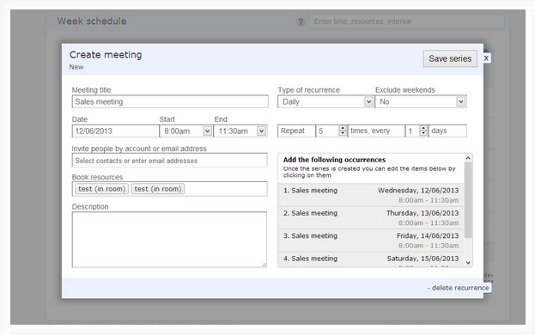

Figure 10

Phone Monthly Calendar User-Interface of Yarooms

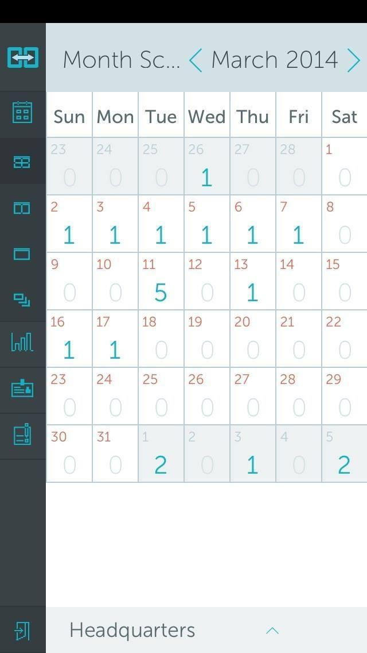

Figure 11

Phone Meeting User-Interface of Yarooms

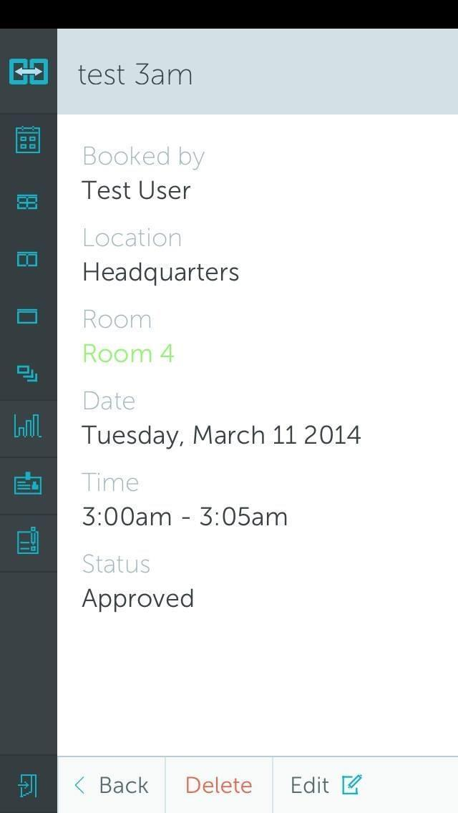

Figure 12

Example of an Office Map in Yarooms

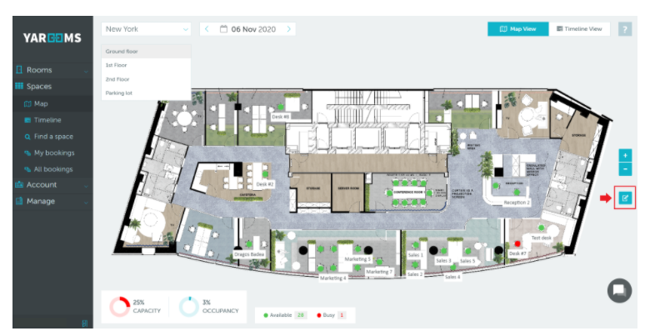

**Project Synthesis**

There are multitudes of industries that have used and still use to date a central reservation system. What once started from Airlines, and is now implemented across hotels, travel agencies, and many others proves to show how useful and efficient it is to use. The proponents now aim to introduce this system to the Pamantasan ng Lungsod ng Valenzuela for the benefit of both students and professors. The main difference between a school reservation system and a Hotel reservation system or any other type of reservation system used commercially is the existence of the “unique rules” that a school has. An article from Ecobook (n.d.) indicated that schedules of classrooms would prioritize the classes of students first and foremost, and there would also be instances of reservations to be done for laboratory activities, which contain equipment that needs to be regulated for equal usage of the students, as well as school events which usually needs a lot of resources to be planned properly. It is not like there no system comparable to a reservation in other schools, nor was it ignored. An example is a study made in the libraries in Fordham University, which can be found in the review of related studies. Although the study did indeed talk about reservations, it was mostly about creating new rooms in the library of the said school, while using Google Calendar, a third-party time-management, and scheduling service by Google to set reservations, contrary to the proponent’s proposal of creating a website specifically catered for the school itself. Another example is also the booking system of the University of Washington. Compared to what Fordham University implemented, the University of Washington has their reservation online via their school website however restrictions can be seen in the process in which only professors can freely create reservations, while students can only view them. In case of students wanting to apply for a reservation, it requires them to personally email the person in charge before said in charge starts processing the reservation.

PLVRS aims to become a reservation system where both students and professors can be classified as users, and have equal access to reservation rights. It is a system that aims to improve the experience of users wanting to ask for a reservation, as well as helping the GSO in managing both equipment and reservation information that they hold. It also aims to reduce the need for personal interaction between the user and the GSO to an absolute minimum.

**CHAPTER 3**

**RESEARCH DESIGN AND METHODOLOGY**

**3.1 Development Model**

Figure 13

Incremental Model Diagram

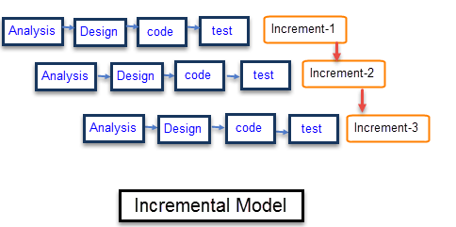

The Incremental Development Model consists of the step-by-step process of requirements specifications, designing, coding, and testing where it provides a series of versions with each version being made up of the previous versions together with the ongoing features for that increment. After every increment, a different version of the system is made with concerns to the development requirements. The proponents have decided to use this model because it will let the stakeholder know the current development of the system which will be always open for revisions and recommendations that will also grant room for improvements. It also sets a clear view of what the proponents need to do within its development time frame. As a result of its flexibility in designing, coding, and testing, the incremental development model is commonly used to effectively develop software for businesses to show to the users or stakeholders the progress of the system. Furthermore, this kind of development will also be applicable for an established university that will serve hundreds of users and possess the possibility to be used in the future, hence delivery of satisfaction for every version of the system must be obtained.

The incremental model has 4 steps/phases per increment. Analysis phase, where the proponents would study the requirements and specifications that the specific increment needs. Design phase, where the proponents would create a design for the functions that the increment would have to better understand the process. Code phase, where the specific function needed is coded into the product. Lastly, the Test phase, where the coded function is tested to understand whether it works properly individually and in conjunction with other functions connected made through previous phases (if there are any). Each increment adds a new function towards the previous increments, with the first increment containing the basic core function of the system.

**3.2 Requirement Analysis**

Figure 14

Data Flow Diagram Level 0 of PLVRS for Requirement Analysis

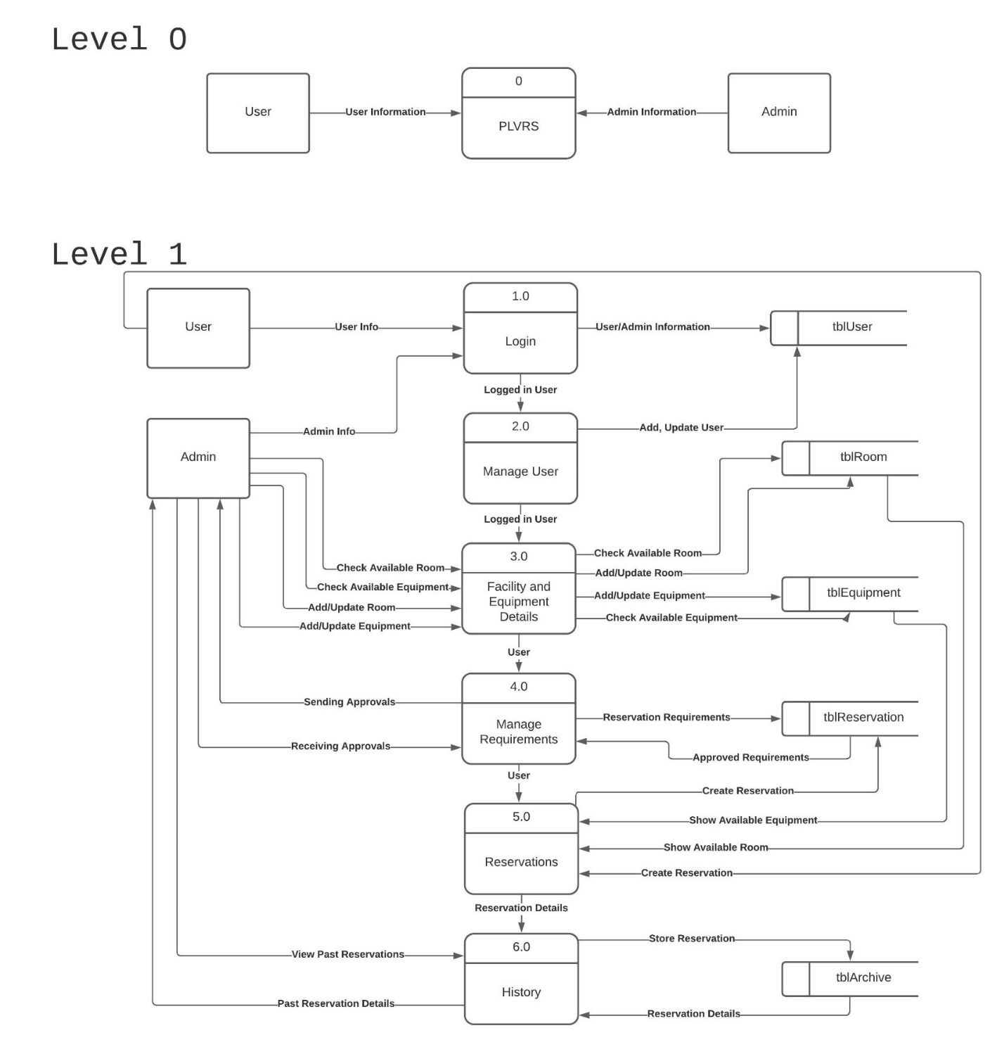

Level 0 diagram shows how both user and admin can interact with the system. PLVRS requires the users to input data for the system to do its main job, to make a reservation for the users.

**3.3 Project Description**

The purpose of this project is to develop a room and equipment reservation system for the PLV-GSO to have a well-organized, systematic, and proper way of making a reservation by strictly following the guidelines and policies for reserving which will lessen the needs for personal meetings between the user and the GSO. In addition, the system will help the GSO to store and manage the records of the reservation made, inventory, and maintenance reports which are the primary data of the reservation system. Below are the functional requirements of the PLVRS that will be utilized to meet the said purposes:

1. The system lets the user and administrator login and log out.
2. The system should be able to display an error if there is already an existing account.
3. Only the administrators will be able to create more administrator accounts while users can only create one account.
4. Both administrators and users will be able to view the updated schedule of reservations in the calendar.
5. The system should be able to update the reservation details on the calendar.
6. The users will be able to register an account using their details and an attachment image of their valid ID.
7. The users will be able to edit their profiles.
8. The administrator will be able to review the user’s registration and verify them.
9. The system will be able to record the registered users' data.
10. The verified users should be able to request, reschedule, and cancel reservations.
11. The system should be able to not grant the reservation to be submitted if it's not 3 days before the desired date.
12. The administrator will be able to review the reservations made by the verified users and click if the reservation is approved/declined.
13. The system should be able to not grant the reservation to be submitted if there is no attachment of the letter of approval.
14. The system should be able to notify the users about their reservation statuses and the administrator about the scheduled reservations.
15. Only the administrator will be able to override the reservations by creating a reservation that the desired date is still available.
16. Only the administrator will be able to modify the scheduled reservations and, the rooms and equipment.
17. Only the administrator will be able to generate a monitoring sheet.
18. The system should be able to update the inventory every time the rooms and equipment are modified.
19. Only the administrator will be able to view the archive of reservations made.
20. Only the administrator will be able to print a report of a specified reservation ID.
21. The system should be able to print one-pager reservation details.
22. The administrator can contact the users via email through the system.
23. The system should be able to notify the users when there is an email from the administrator.
24. The system should be able to notify the users about their registration and reservation via email.
25. The system should be able to resize its screen space for all types of devices.
26. The administrator will be able to modify the user’s profiles and update their reputations.
27. The system should be able to restrict non-verified users to make a reservation.
28. The system should be able to display the guidelines and policies of rooms and equipment reservations.
29. The system should be able to have a weekly backup of the data.
30. The web server should be able to load the web application.
31. All buttons in the system must be working.
32. The color or theme of the system, when viewed on a desktop, should be the same when viewed on a mobile phone.
33. The database should be able to store the users and administrator data.
34. The database should be able to store the reservations made both approved and declined.
35. The database should be able to store the details in rooms and equipment.

**3.4 Project Design**

Project Designs are used to illustrate the functionalities, information, user interface, and data stored in a system. These are helpful to easily understand each part of the PLVRS. Data Flow Diagrams (DFD) will clearly show how the information goes through the whole system that is categorized by levels. For each level, it shows how easy to complex the diagram will be. The most basic data flow diagram is the Level 0 DFD which provides a broad view of the system’s information flow while Level 1 DFD is still a general view but it provides more complexity since it shows that a single process can be broken down into its sub-processes. Lastly, the Level 2 DFD is used to show the detailed process of how the data flow in the system.

Moreover, a use case diagram is used to model the functionalities of what an actor can do to the system and the use case scenario contains detailed information about the use cases that are used for user’s capability documentation. Aside from the users’ functionalities, the relationship of each entity such as the objects, people, or things is illustrated to show how these entities are related to each other which is called Entity Relationship Diagram (ERD). The data dictionary is used to explain each object that can be seen from the ERD. These are helpful especially for the database administrator to easily understand the relationship of the entities and the data allocation.

The diagrams mentioned above explains the back end of the system while to illustrate the front end of a system, a screenshot of those is important. Each screenshot of the user interface will guide the user to navigate the system firsthand. This will show the icons, buttons, displays where the data from the back-end are visually seen and where the system itself lets the user perform their functionalities.

**3.4.1 Proposed System Context Diagram** (0 Diagram)

Figure 15

Data Flow Diagram Level 0 Software Architecture

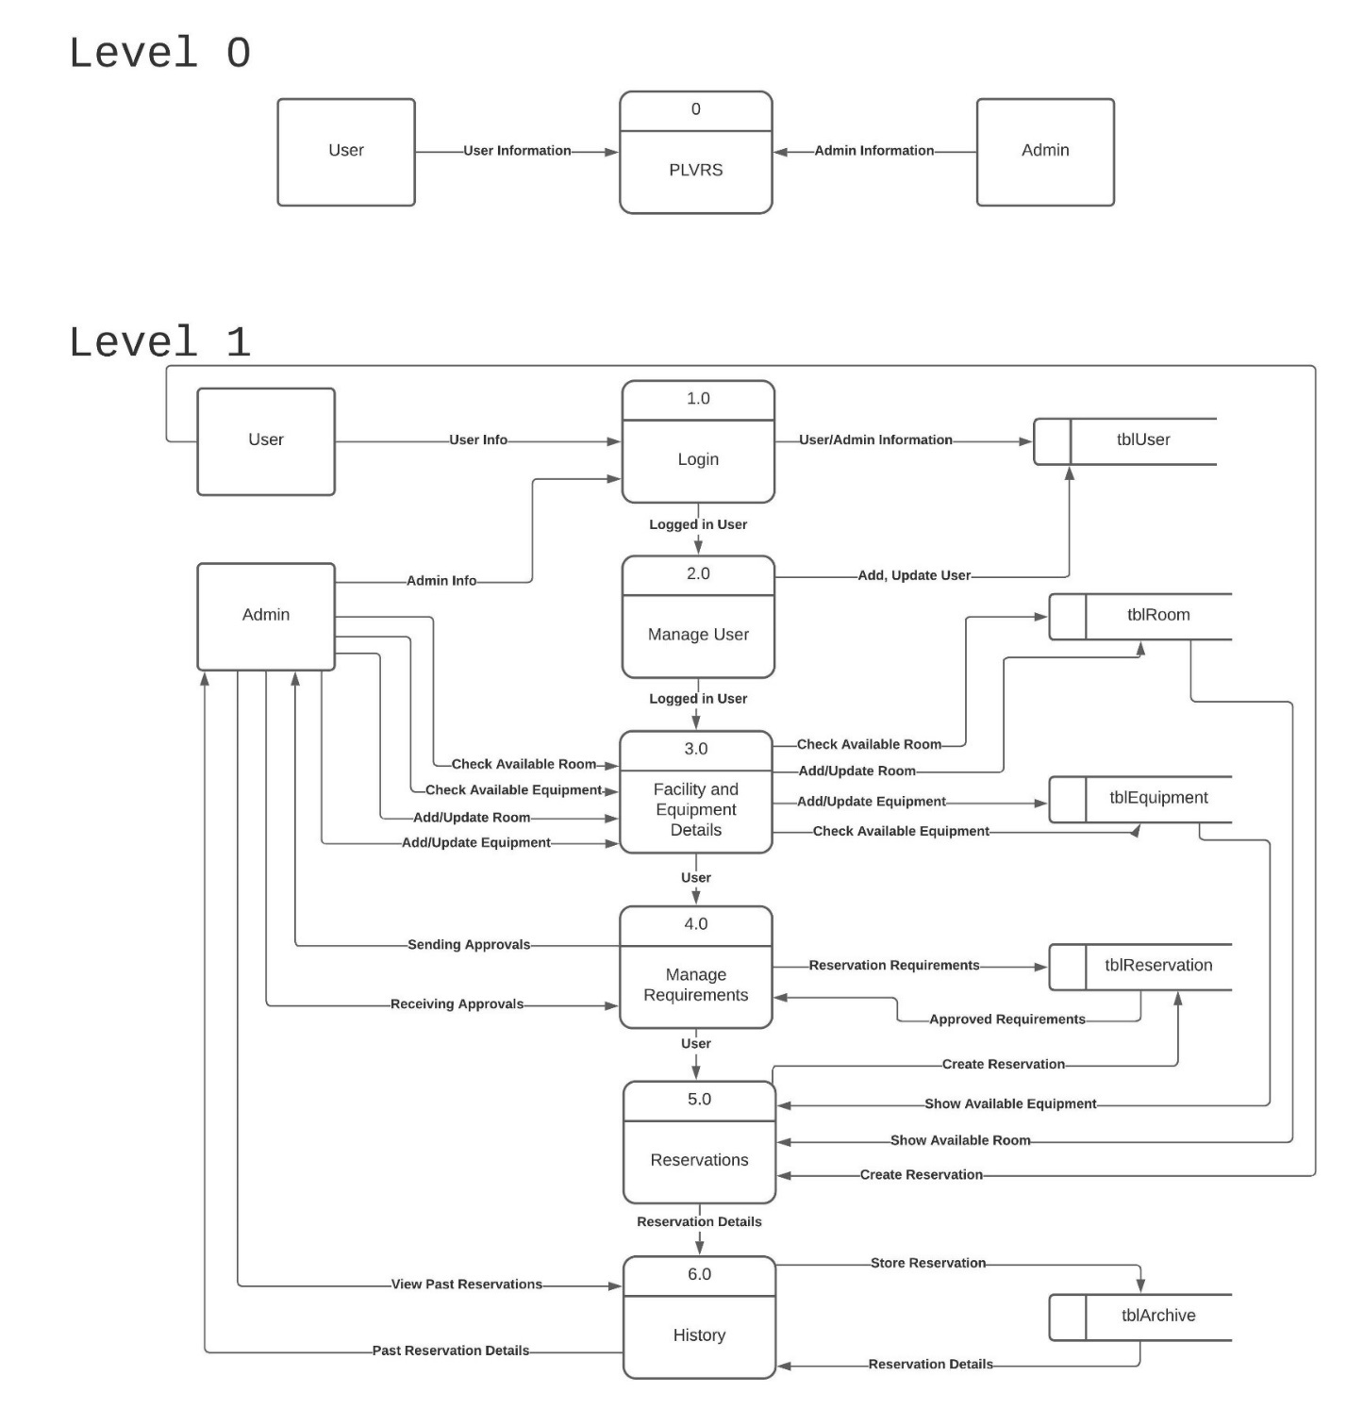

Here at level 0, the data flow diagram shows that the user and admin are both capable of using the system.

**3.4.2 Proposed System Level 1 Diagram**

Figure 16

Data Flow Diagram Level 1 of PLVRS

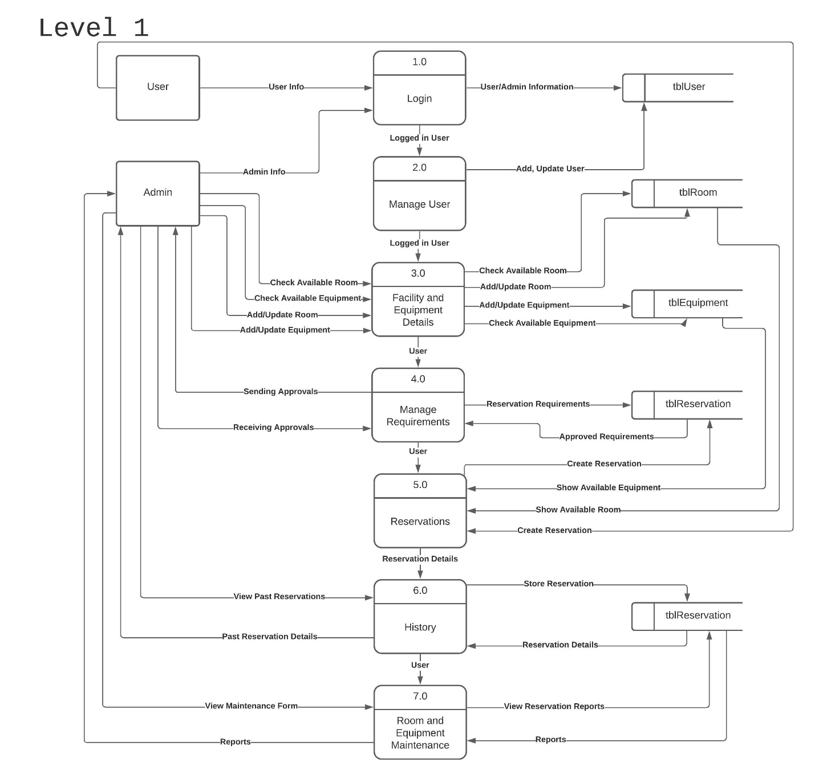

Level 1 of our data flow diagram shows the main functions of our system. The first process is the login function (1.0) where both user and admin can login to their account and the data will go to tblUser. The second is the logged-in user can manage his/her account, however, the admin is the only one who can add an account. The third is the facility and equipment details (3.0) where the admin can check available rooms, and equipment, and also admin can add or update both room and equipment, the data needed for this step is from tblRoom and tblEquipment. The fourth process is managing the requirements (4.0) needed for the reservation, this is the time where the requirements needed for the reservation are approved or declined by the admin. The fifth process is the reservation (5.0), after checking all of the requirements needed, users can pick what room and equipment they needed and the availability of those requests are checked in tblRoom and tblEquipment. Process 6.0 is the storing of data in an archive for the admin to check the history if needed. Every after reservation, the admin always checks the condition of the room and equipment. Process 7.0 serves as the monitoring form for the admin and generating damages reports if there are any.

**3.4.3 Proposed System Level 2 Diagram**

Figure 16.1

Data Flow Diagram Level 2 of PLVRS Process 1.0

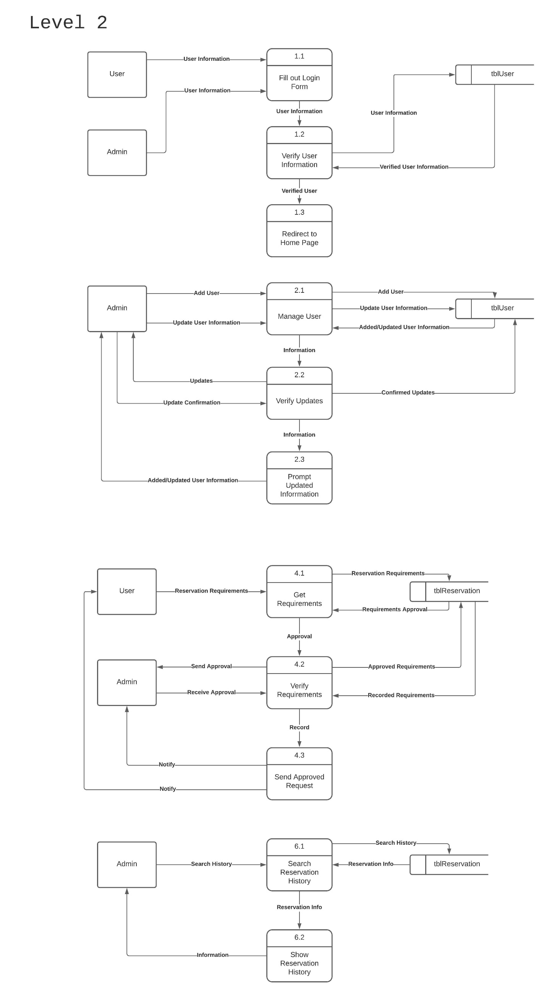

This is the breakdown of DFD level 1 process 1.0. Both user and admin should input the information needed for them to log in (1.1) into the system. Then the information should be verified.

Figure 16.2

Data Flow Diagram Level 2 of PLVRS Process 2.0

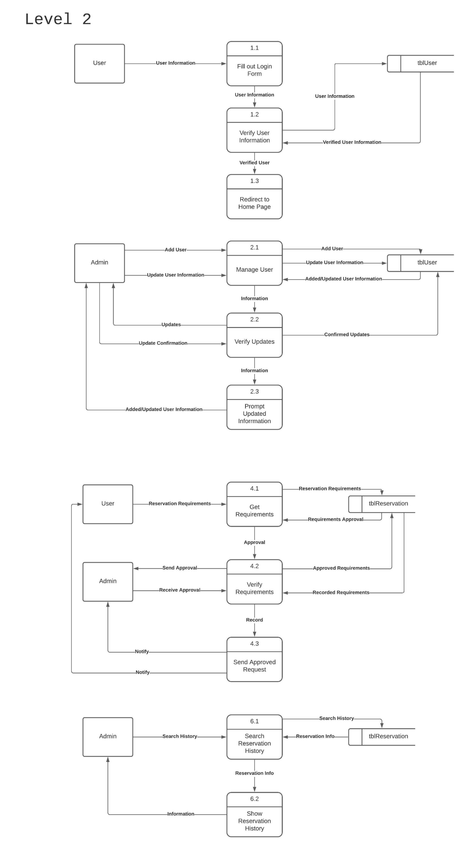

(1.2) by our system, to ensure that the user is already registered, the data to be used for account verification is stored in tblUser. After the verification, the system should redirect the user to the website (1.3).

Process 2.0 shows how the management of user information works. Admin is the one who is capable of accepting registrations or adding users, the admin is also capable of updating user’s information (2.1), all the updates must be stored in tblUser. After adding or updating user information, the admin should verify (2.2) and confirm if those updates are correct, then once the admin already verified the update. The system should inform the admin that updating of information is successful (2.3).

Figure 16.3

Data Flow Diagram Level 2 of PLVRS Process 3.0

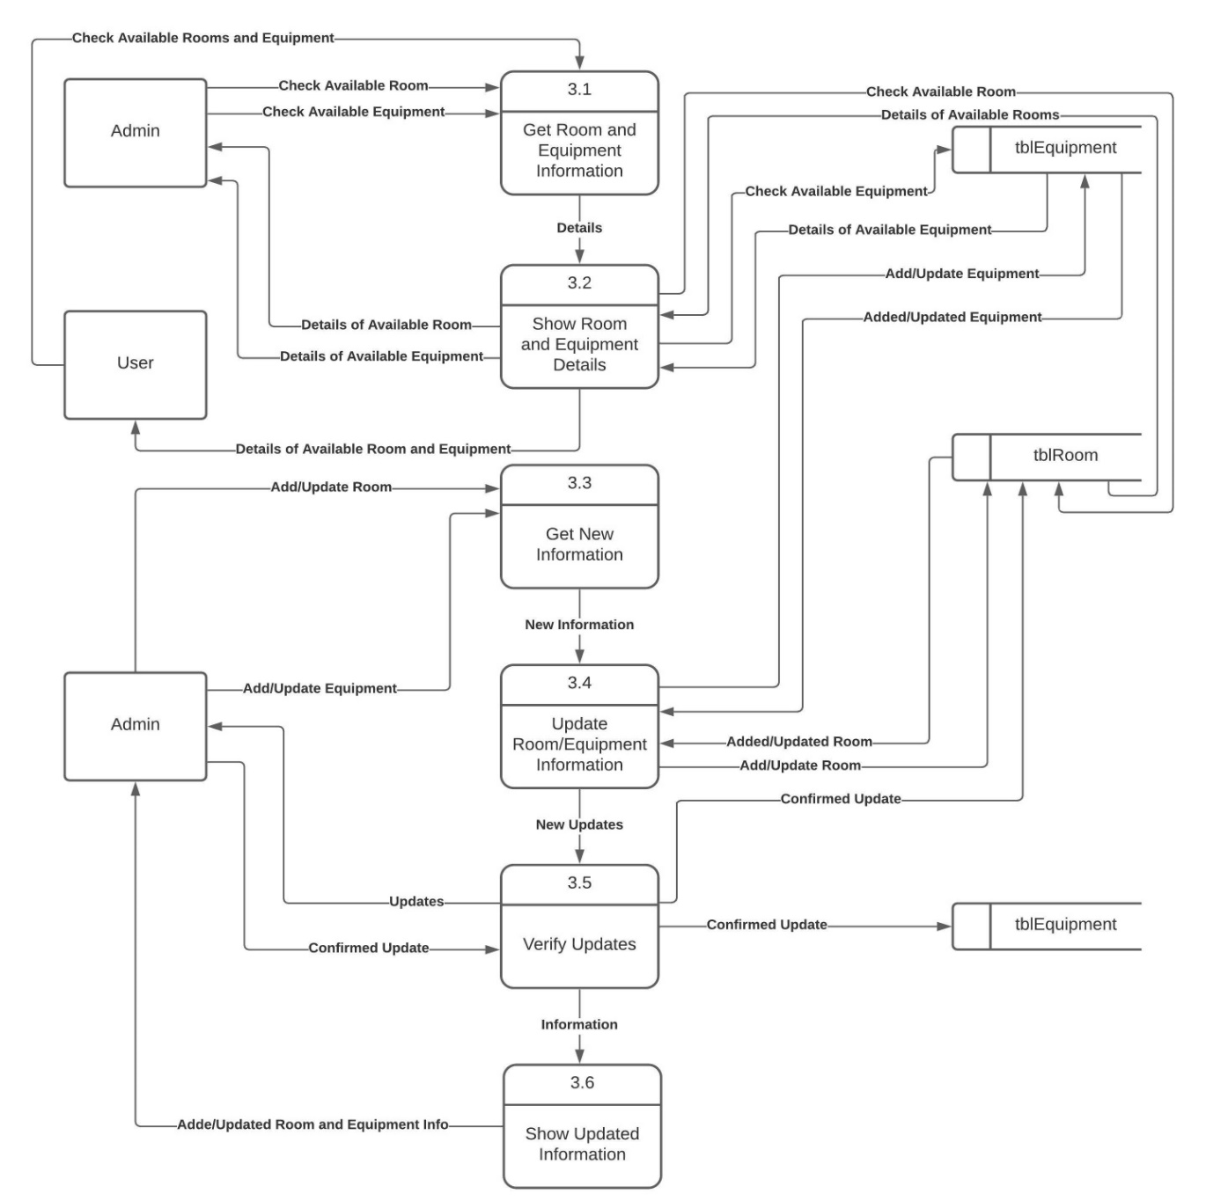

Process 3.0 shows how the management of rooms and equipment works. In this stage, the user can only view available rooms and equipment which can be reserved while the admin can view, update, and add available room and equipment to the system. To check if there is an available room and equipment, both user and admin can view it on the website (3.1), then the system must show the available one, all the data that is needed for this action is fetched from tblEquipment and tblRoom, and after that, the system should show the available room and equipment for the user to borrow (3.2).

Process 3.3 shows how the admin can add or manipulate the data. First, the admins should input the information to be updated or added to the system, then process 3.4 will add or update the data that the admin inputs into the system, all the data should be stored inside tblEquipment and tblRoom depending on where does the update of admin belongs. Then, verification should happen to ensure that the data entered by the admin is correct (3.5). After that, the system will show the admin the updated information (3.6).

Figure 16.4

Data Flow Diagram Level 2 of PLVRS Process 4.0

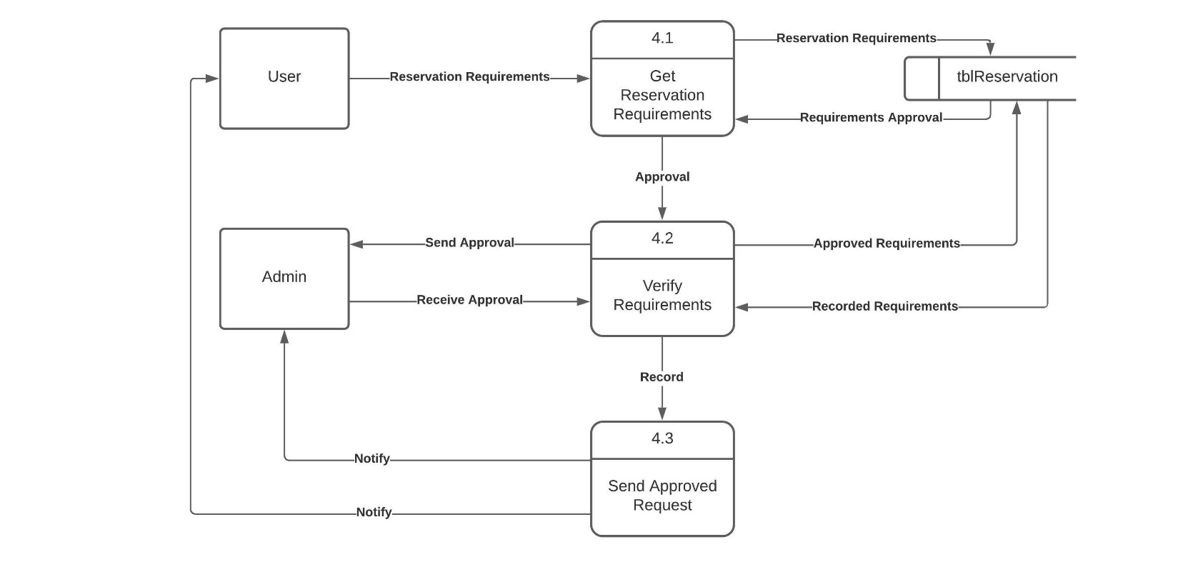

Process 4.0 is all about checking of requirements needed for the user to be able to reserve room and equipment. User should send all of the requirements needed in our system (4.1), then the system should verify if the requirements are complete with the help of the admin (4.2), after the verification, the verified requirements will be recorded in tblReservation then the system should inform both admin and user that the requirements needed are accepted (4.3).

Figure 16.5

Data Flow Diagram Level 2 of PLVRS Process 5.0

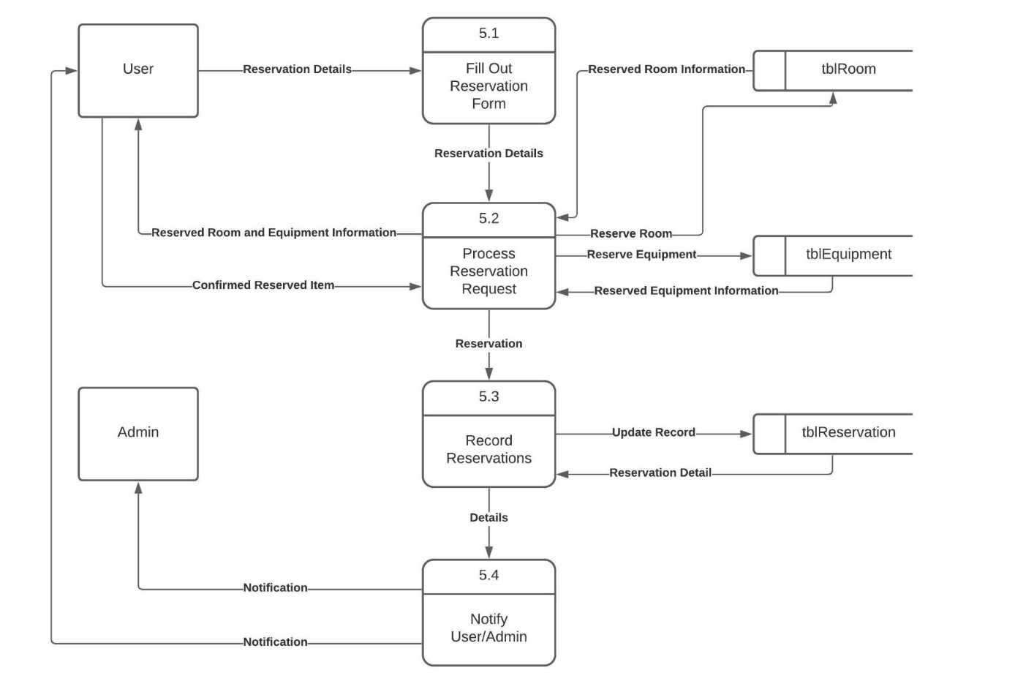

Process 5.0 is about how the system lets the user create reservations. If the user meets the requirements needed at process 4.0, the system will let the user create a reservation at process 5.0. User should fill out the reservation form provided by the system (5.1), then the system will process the reservation, it will reserve the room and equipment reserved by the user if it is available, all the data for this action will be fetched in tblRoom and tblEquipment (5.2), after that, the user should confirm that the system shows the right room and equipment that the user request. After the confirmation, the reservation will be recorded in tblReservation (5.3), after the system creates a record of the reservation, the system should notify the admin and user about the reservation (5.4).

Figure 16.6

Data Flow Diagram Level 2 of PLVRS Process 6.0

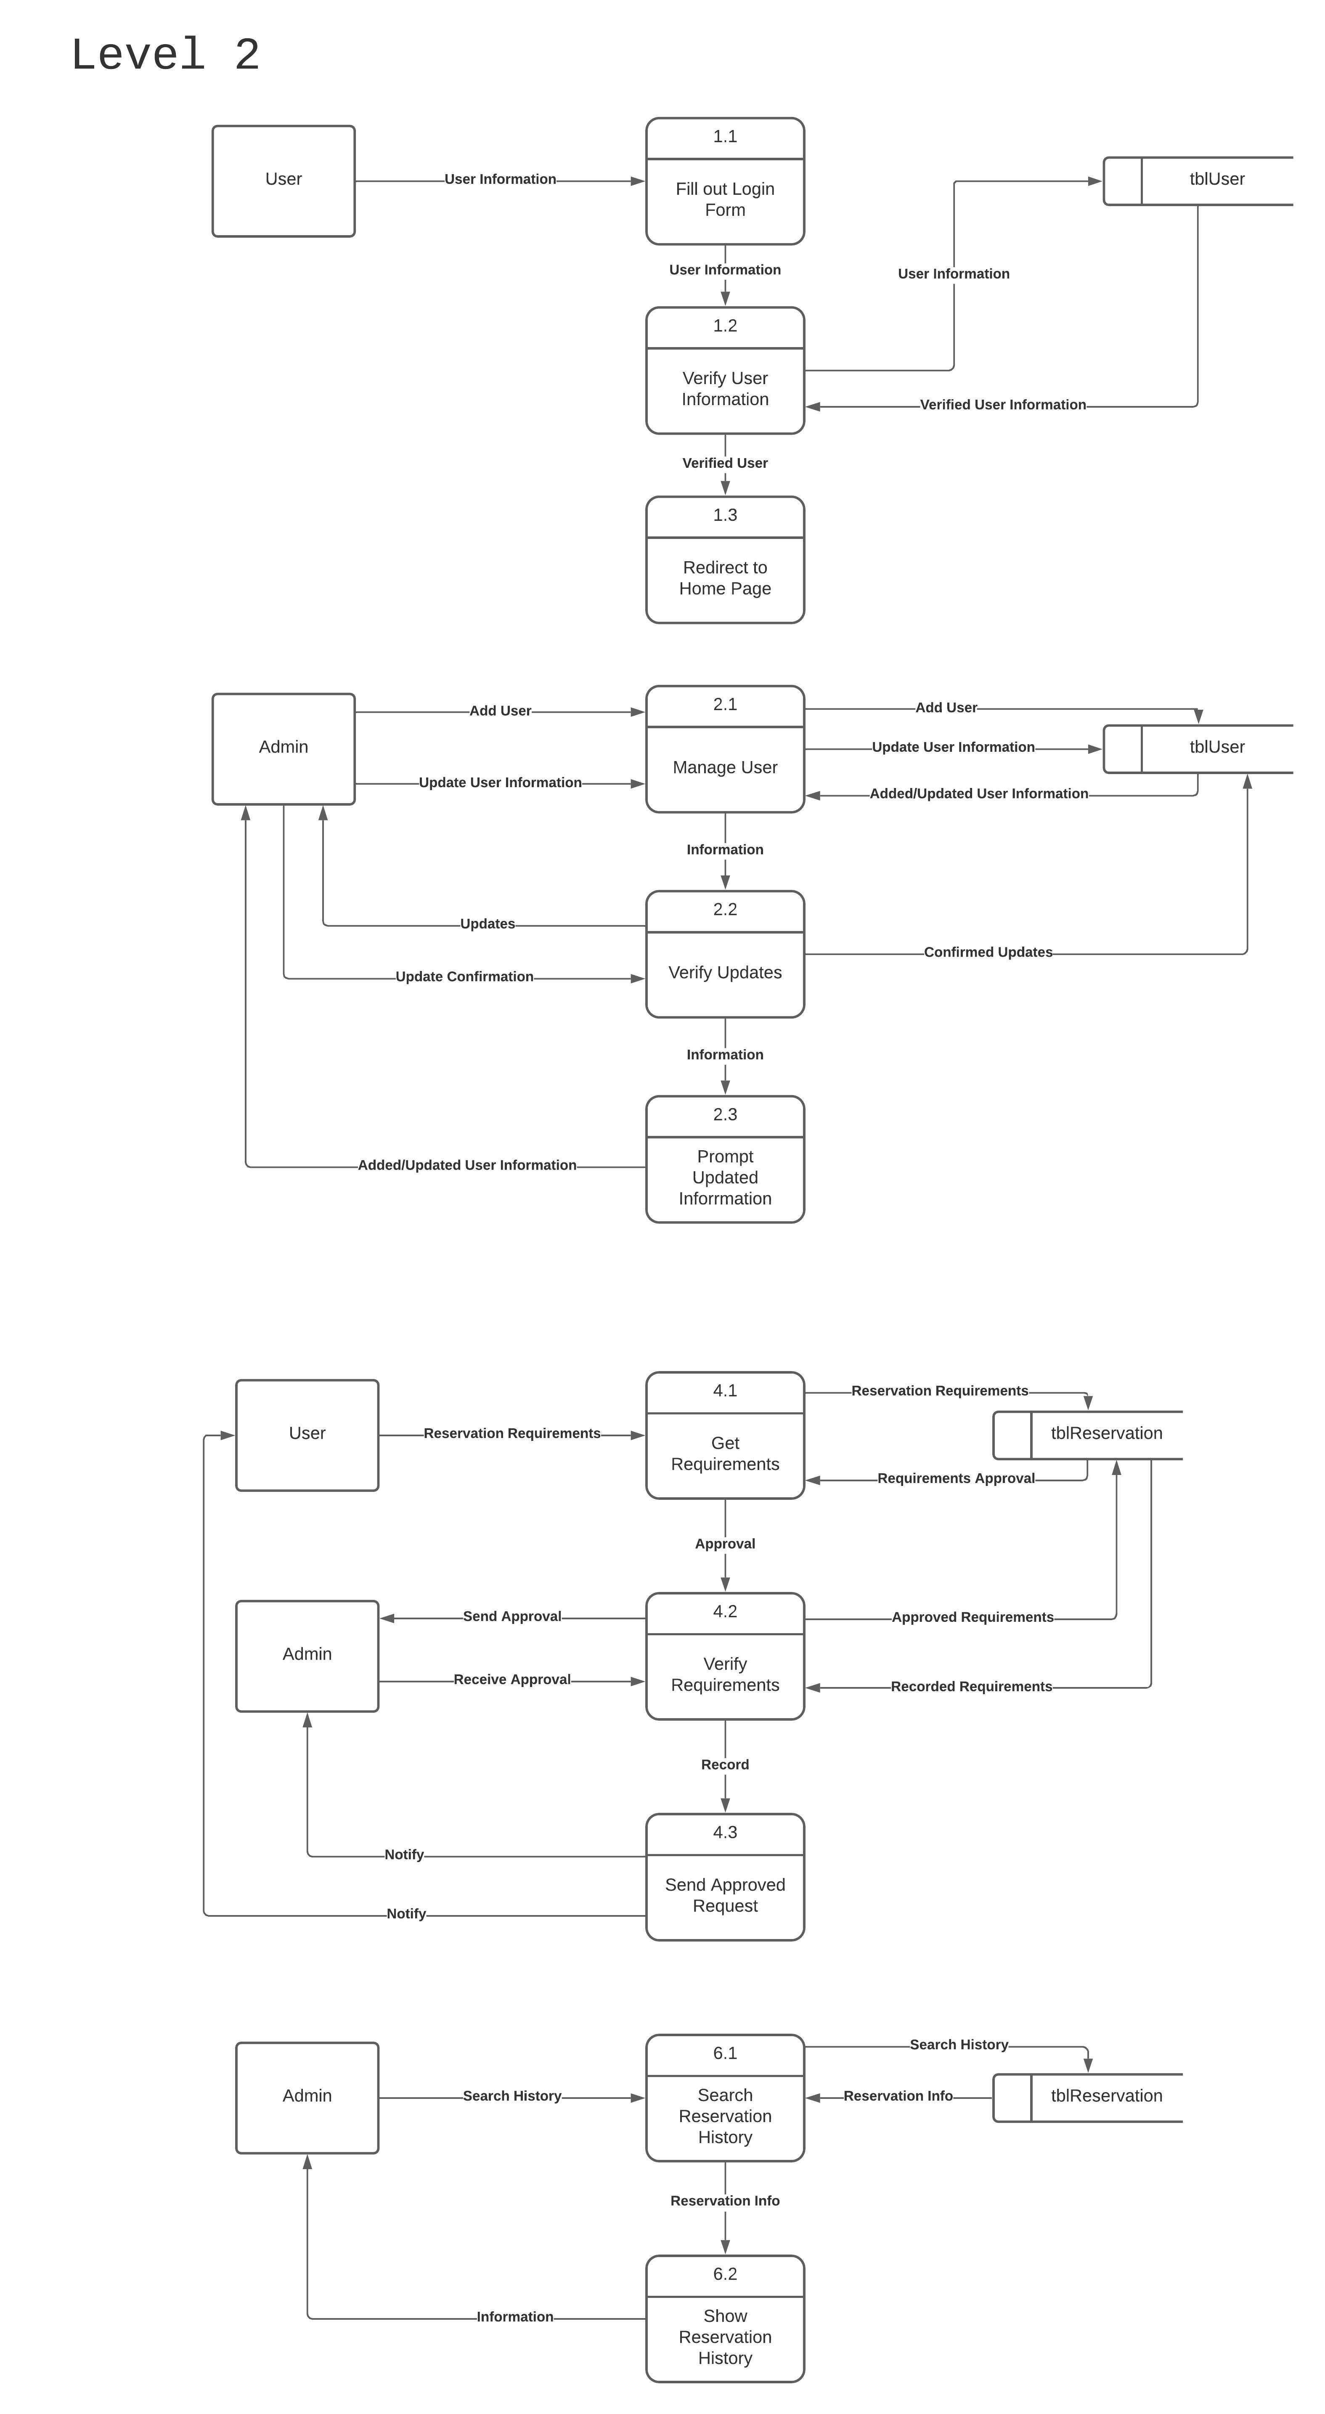

Process 6.0 is for the admin only; it gives access to the admin who wanted to view present or past reservations that the system recorded. Admin should input the information or search for the reservation (6.1), all the data needed for this action is stored in tblReservation. After the system finds the right reservation, it should show all the information to the admin (6.2).

Figure 16.7

Data Flow Diagram Level 2 of PLVRS Process 7.0

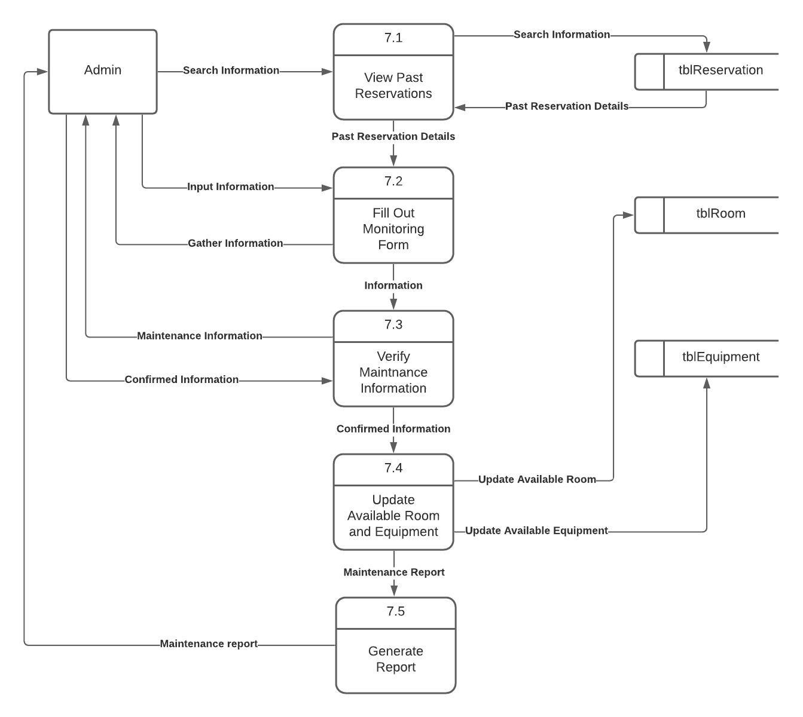

Process 7.0 is for the monitoring form. If there are any damages found in the room or equipment, the admin should search for past reservation first to see who is the last user of the room or equipment, the data for this action is gathered from tblReservation (7.1), after gathering all the data needed, the admin should fill out monitoring form provided by the system (7.2), after filling out all the information needed, the admin should verify all the information (7.3), then after the confirmation, the system will update tblRoom or tblEquipment depending if where the damage was found (7.4). After the update, the system will generate a report for the admin (7.5).

**3.4.4 Use Case Diagram**

Figure 17

Use Case Diagram of PLVRS

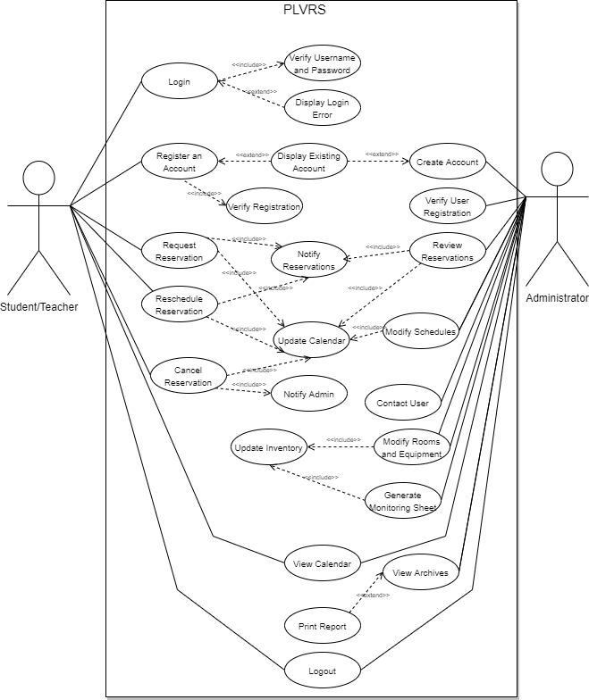

**3.4.5 4.5 Use Case Scenario**

|  |  |
| --- | --- |
| NO. | 1 |
| USE CASE NAME | Login |
| SUMMARY | The student/teacher can log in to their account. |
| DEPENDENCY | Included use case: Verify Username and Password   * The system will verify the users' input to the database. |
| ACTORS | Student/Teacher |
| PRECONDITIONS | The student/teacher is registered and knows their correct username and password. |
| MAIN SEQUENCE | 1. The student/teacher will enter the username and password. 2. The system will check the username and password on the database. 3. The student/teacher will be logged on. |
| ALTERNATE SEQUENCE | If the username and password are not matched, the textbox will turn red which means there’s a login error.   1. Enter the correct username and password again. |
| NON-FUNCTIONAL REQUIREMENTS | Security   * The username must contain at most 20 characters. * Password must consist of 1 capital letter, 1 symbol, 1 number, and at least 8 characters.   Recoverability   * Users can recover their account via Forgot Password   Data Integrity   * Users’ username and password are in hash when stored in the database. |
| POST CONDITION | At the end of the use case, the user is successfully logged on to the system. |

|  |  |
| --- | --- |
| NO. | 2 |
| USE CASE NAME | Register an Account |
| SUMMARY | The student/teacher can register an account. |
| DEPENDENCY | Included use case: Verify Registration   * The student/teachers’ data will be verified first. |
| ACTORS | Student/Teacher |
| PRECONDITIONS | The student/teacher has a PLV ID, is currently enrolled or working at the university, and is stored on the university’s system. |
| MAIN SEQUENCE | 1. The student/teacher will input their full name, email address, contact number, and ID number. 2. The student/teacher will attach their PLV ID. 3. The system will store the users’ data in the database. 4. The student/teacher's request for registration will be queued to the administrator’s dashboard. |
| ALTERNATE SEQUENCE | If the system checked that there is an existing account, a prompt will be displayed that there is already an existing account.   1. The student/teacher can now log in to their account. |
| NON-FUNCTIONAL REQUIREMENTS | Security   * The email address should have the correct address. * All fields must have a response. * Password must consist of 1 capital letter, 1 symbol, 1 number, and at least 8 characters.   Data Integrity   * Student/teachers’ data are hashed when stored in the database. |
| POST CONDITION | At the end of the use case, the student/teacher is now registered. |

|  |  |
| --- | --- |
| NO. | 3 |
| USE CASE NAME | Request Reservation |
| SUMMARY | The student/teacher can request a reservation and will be notified once their reservation is approved/declined. |
| DEPENDENCY | Included use case: Notify Reservation   * The system will notify the user if their request for a reservation is approved/declined.   Included use case: Update Calendar   * The system will update the calendar if the requested reservation is approved. |
| ACTORS | Students/Teachers |
| PRECONDITIONS | The student/teacher that is requesting a reservation is registered, requirements and guidelines are met, and the reservation form date is fully responded to. |
| MAIN SEQUENCE | 1. The student/teacher will go to the reservation page. 2. The student/teacher will click their desired date. 3. The system will ask the user to fill out the reservation form. 4. The student/teacher will attach the soft copy of their letter of approval. 5. The student/teacher will click submit. 6. The system will queue the reservation to the administrator dashboard for reviewal. |
| ALTERNATE SEQUENCE | N/A |
| NON-FUNCTIONAL REQUIREMENTS | Performance   * Load response will be based on the webserver.   Regulatory   * All fields on the reservation form are required to be filled out. * The request should be 3 days before the desired date. * A letter of approval should be attached before submitting the reservation.   Serviceability   * The system will show the status of the student/teachers’ reservation request. |
| POST CONDITION | At the end of the use case, the student/teacher successfully submitted their request for a reservation. Once approved, the reservation schedule will reflect in the calendar. |

|  |  |
| --- | --- |
| NO. | 4 |
| USE CASE NAME | Reschedule Reservation |
| SUMMARY | The student/teacher can reschedule their reservation and will be notified once their request is approved/declined. |
| DEPENDENCY | Included use case: Notify Reservation   * The system will notify the student/teacher if their request for a reservation is approved/declined.   Included use case: Update Calendar   * The system will update the calendar if the rescheduled reservation is approved. |
| ACTORS | Student/Teacher |
| PRECONDITIONS | The student/teacher has an existing reservation and requesting to reschedule 3 days before the current reservation. |
| MAIN SEQUENCE | 1. The student/teacher will request to reschedule their reservation. 2. The administrator will review it. 3. The system will notify the student/teacher about their approved/declined rescheduled reservation. 4. The system will update the calendar. |
| ALTERNATE SEQUENCE | N/A |
| NON-FUNCTIONAL REQUIREMENTS | Performance   * Load response will be based on the webserver.   Regulatory   * The guidelines and policies in rescheduling should be met.   Serviceability   * The system will show the status of the student/teacher request on the rescheduled reservation. |
| POST CONDITION | At the end of the use case, the student/teacher successfully rescheduled their reservation and the calendar is updated. |

|  |  |
| --- | --- |
| NO. | 5 |
| USE CASE NAME | Cancel Reservation |
| SUMMARY | The student/teacher can cancel their reservation and the administrator will be notified. |
| DEPENDENCY | Included Use Case: Notify Admin   * The system will notify the administrator that a specific reservation is canceled.   Included Use Case: Update Calendar   * The system will update the calendar. |
| ACTORS | Students/Teacher |
| PRECONDITIONS | The student/teacher has a requested reservation or an approved reservation. |
| MAIN SEQUENCE | 1. The student/teacher will cancel the reservation. 2. The system will notify the administrator. 3. The system will update the calendar. |
| ALTERNATE SEQUENCE | N/A |
| NON-FUNCTIONAL REQUIREMENTS | Performance   * Load response will be based on the webserver. |
| POST CONDITION | At the end of the use case, the student/teacher has canceled their reservation and the calendar is updated. |

|  |  |
| --- | --- |
| NO. | 6 |
| USE CASE NAME | View Calendar |
| SUMMARY | The student/teacher and administrator can view the scheduled reservations on the calendar. |
| DEPENDENCY | N/A |
| ACTORS | Students/Teacher  Administrator |
| PRECONDITIONS | The student/teacher and administrator are registered. |
| MAIN SEQUENCE | 1. The student/teacher/administrator will go to the calendar page. 2. The student/teacher/administrator will view the calendar. 3. The system will show the updated calendar. |
| ALTERNATE SEQUENCE | N/A |
| NON-FUNCTIONAL REQUIREMENTS | Performance   * Load response will be based on the webserver. |
| POST CONDITION | At the end of the use case, the student/teacher/administrator has viewed the updated calendar. |

|  |  |
| --- | --- |
| NO. | 7 |
| USE CASE NAME | Logout |
| SUMMARY | The student/teacher/administrator can log out of their account. |
| DEPENDENCY | N/A |
| ACTORS | Students/Teachers  Administrator |
| PRECONDITIONS | The student/teacher and administrator are currently logged on to the system. |
| MAIN SEQUENCE | 1. The student/teacher/administrator will click the menu button. 2. The student/teacher/administrator will click the log-out button. 3. The system will log out the users/administrator account. |
| ALTERNATE SEQUENCE | N/A |
| NON-FUNCTIONAL REQUIREMENTS | Performance   * Load response will be based on the webserver.   Security   * Upon logging out, when the back button is clicked, there will be no instances that the student/teacher/administrator is logged in again. |
| POST CONDITION | At the end of the use case, the student/teacher and administrator have successfully logged out on the system. |

|  |  |
| --- | --- |
| NO. | 8 |
| USE CASE NAME | Create Account |
| SUMMARY | The administrator can create more accounts for the administrator that does not have an existing account. |
| DEPENDENCY | N/A |
| ACTORS | Administrator |
| PRECONDITIONS | The administrator can create more accounts, already logged on the system, has the necessary information for the new administrator such as full name, email address, position, and PLV ID. |
| MAIN SEQUENCE | 1. The administrator will go to the create account. 2. The administrator will fill out the necessary information. 3. The administrator will click create an account. 4. The system will store the new data. 5. The system will update. 6. The system has an added administrator. |
| ALTERNATE SEQUENCE | If the system checked that there is an existing account, a prompt will be displayed that there is already an existing account. |
| NON-FUNCTIONAL REQUIREMENTS | Security   * The email address should have the correct address. * All fields must have a response.   Data Integrity   * Administrators’ data are hashed when stored in the database.   Performance   * Load response will be based on the webserver. |
| POST CONDITION | At the end of the use case, the administrator has added a new administrator account. |

|  |  |
| --- | --- |
| NO. | 9 |
| USE CASE NAME | Verify User Registration |
| SUMMARY | The administrator will verify the users that have requested registration. |
| DEPENDENCY | N/A |
| ACTORS | Administrator |
| PRECONDITIONS | The administrator has logged on to the system and has the record of students/teachers currently enrolled/working at the university. |
| MAIN SEQUENCE | 1. The administrator will go to the dashboard of users’ registration. 2. The administrator will verify the users. 3. The administrator will approve/declined students'/teachers’ registration. 4. The system will store updated users’ data. |
| ALTERNATE SEQUENCE | N/A |
| NON-FUNCTIONAL REQUIREMENTS | Serviceability   * The verification of the user’s registration will be based on the presence of the administrator.   Performance   * Load response will be based on the webserver. |
| POST CONDITION | At the end of the use case, the administrator has fully verified the user’s registration. |

|  |  |
| --- | --- |
| NO. | 10 |
| USE CASE NAME | Review Reservations |
| SUMMARY | The administrator will review all requested reservations whereas the system will notify the approved/declined reservations and the system will then update the calendar if there is an approved reservation. |
| DEPENDENCY | Included Use Case: Notify Reservations   * The system will notify the administrator regarding the scheduled reservations.   Included Use Case: Update Calendar   * The system will update the calendar once there are approved reservations by the administrator. |
| ACTORS | Administrator |
| PRECONDITIONS | The administrator has the requested reservations, is logged on the system, and has the letter of approval from the requestor. |
| MAIN SEQUENCE | 1. The administrator will check if there is a pending reservation request. 2. The administrator will review the reservation. 3. The administrator will approve/decline the reservation. 4. The system will update the calendar. 5. The requested reservation will be removed from the queue. |
| ALTERNATE SEQUENCE | N/A |
| NON-FUNCTIONAL REQUIREMENTS | Performance   * Load response will be based on the webserver. * The status of the requested reservation will be displayed.   Availability   * The requested reservation will be reviewed immediately upon the availability of the administrator. |
| POST CONDITION | At the end of the use case, the administrator has approved reservations and the system has updated the calendar. |

|  |  |
| --- | --- |
| NO. | 11 |
| USE CASE NAME | Contact User |
| SUMMARY | The administrator can contact the user via email. |
| DEPENDENCY | N/A |
| ACTORS | Administrator |
| PRECONDITIONS | The administrator is currently logged on the system and has an internet connection. |
| MAIN SEQUENCE | 1. The administrator will search for the student/teacher profile. 2. The administrator will click the user’s profile. 3. The administrator will use the email address of the selected user. 4. The administrator will create a message using the system. 5. The administrator will click send. 6. The system will send the message to the email of the selected user. |
| ALTERNATE SEQUENCE | N/A |
| NON-FUNCTIONAL REQUIREMENTS | Performance   * Load response will be based on the webserver. |
| POST CONDITION | At the end of the use case, the administrator has contacted the user. |

|  |  |
| --- | --- |
| NO. | 12 |
| USE CASE NAME | Modify Rooms and Equipment |
| SUMMARY | The administrator can modify the availability of rooms and equipment that can be reserved. |
| DEPENDENCY | Included Use Case: Update Inventory   * The inventory will be updated once the administrator adds and delete a room or equipment. |
| ACTORS | Administrator |
| PRECONDITIONS | The administrator needs to update the rooms and equipment availability. |
| MAIN SEQUENCE | 1. The administrator will go to the modification page. 2. The administrator will add rooms. 3. The administrator will add equipment. 4. The system will update the rooms and equipment availability. |
| ALTERNATE SEQUENCE | Once the rooms and equipment are modified, a monitoring sheet will be created by the system. |
| NON-FUNCTIONAL REQUIREMENTS | Performance   * Load response will be based on the webserver.   Availability   * All rooms and equipment that are recorded will always be available to the users. |
| POST CONDITION | At the end of the use case, the administrator has successfully added rooms and equipment to the system. |

|  |  |
| --- | --- |
| NO. | 13 |
| USE CASE NAME | Generate Monitoring Sheet |
| SUMMARY | The administrator can generate a monitoring sheet per maintenance checking. |
| DEPENDENCY | Included Use Case: Update Inventory   * The inventory will be updated once the administrator lists the available rooms and equipment. |
| ACTORS | Administrator |
| PRECONDITIONS | The administrator is having the monthly/weekly check of their inventory and needs to update the rooms and equipment availability. |
| MAIN SEQUENCE | 1. The administrator will go to the monitoring sheet page. 2. The administrator will list the equipment attributes such as availability, damage, or not. 3. The system will record the monitoring sheet on that day. 4. The system will update the rooms and equipment availability. |
| ALTERNATE SEQUENCE | N/A |
| NON-FUNCTIONAL REQUIREMENTS | Performance   * Load response will be based on the webserver.   Availability   * All rooms and equipment that are recorded will always be available to the users. |
| POST CONDITION | At the end of the use case, the administrator has successfully created a monitoring sheet for their monthly/weekly maintenance. |

|  |  |
| --- | --- |
| NO. | 14 |
| USE CASE NAME | Modify Schedules |
| SUMMARY | The administrator can modify the list of reservations. |
| DEPENDENCY | Included Use Case: Update Calendar   * The system will update the calendar once the administrator added a new reservation. |
| ACTORS | Administrator |
| PRECONDITIONS | The selected reservation has been approved, the desired date and time is still available, and it should be an administrator modifying the schedules. |
| MAIN SEQUENCE | 1. The administrator will click the desired date. 2. The administrator will fill out the necessary information needed for the reservation. 3. The administrator will reserve the date. 4. The system will update the calendar. |
| ALTERNATE SEQUENCE | N/A |
| NON-FUNCTIONAL REQUIREMENTS | Performance   * Load response will be based on the webserver. |
| POST CONDITION | At the end of the use case, the administrator has changed the reservation/added a new reservation and the system updated the calendar. |

|  |  |
| --- | --- |
| NO. | 15 |
| USE CASE NAME | View Archives |
| SUMMARY | The administrator can view all reservations made whether it is approved or declined. |
| DEPENDENCY | N/A |
| ACTORS | Administrator |
| PRECONDITIONS | The administrator has to give the proof of reservation to the user that has an approved reservation. |
| MAIN SEQUENCE | 1. The administrator will view the archive. 2. The administrator will click the reservation ID needed. 3. The system will display the reservation details. |
| ALTERNATE SEQUENCE | If the administrator needed the reservation details for a specific date, the system will print out a report containing the details of the reservation. |
| NON-FUNCTIONAL REQUIREMENTS | Performance   * Load response will be based on the webserver.   Capacity   * The system can print a report one at a time.   Security   * Only the administrator can access and view the archives. |
| POST CONDITION | At the end of the use case, the administrator has successfully viewed the archive of the reservations made. |

**3.4.6 Extended Entity Relationship Diagram**

Figure 18

The Entity Relationship Diagram of PLVRS

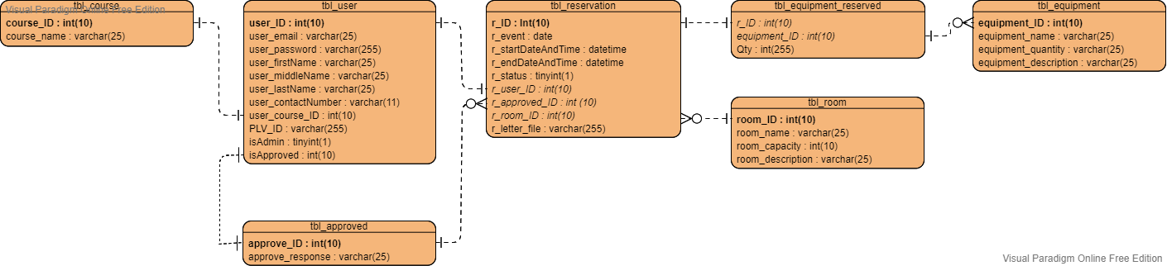

Figure 18.1

The Entity Relationship Diagram of PLVRS Table Course



In figure 18.1, all the data about the course or department of the user and unique identifier for the user is stored in tbl_course.

Figure 18.2

The Entity Relationship Diagram of PLVRS Table Approved



Figure 18.2 is tbl_approved, it shows the unique identifier for the response or approval of the admin.

Figure 18.3

The Entity Relationship Diagram of PLVRS Table User



Figure 18.3 shows the tbl_user, this is the table where all the needed information about the user is stored. All the basic information such as first name, middle name, last name, and contact number is stored here as well as account email, password, and the PLV ID of the user. This table also stores the identification if the user is student/professor or an admin.

Figure 18.4

The Entity Relationship Diagram of PLVRS Table Equipment



Figure 18.4 shows all the content of tbl_equipment, all of the information needed for the equipment is stored here. It contains the unique identifier for the equipment, the name of the equipment, the number of equipment, and the information about the equipment or the description.

Figure 18.5

The Entity Relationship Diagram of PLVRS Table Room



Figure 18.5 is the tbl_room, all the data about the rooms is stored here. This table stores a unique identifier for each room, name of the room, how many people a room can accommodate or the capacity oof the room, and the description of the room.

Figure 18.6

The Entity Relationship Diagram of PLVRS Table Reservation



Figure 18.6 shows the tbl_reservation where all the reservations is stored. This table contains the unique identifier for the reservation made by the user, information about what kind of event, the date and time of the event specifically the start and end time, the status if the event is still ongoing or finished, the files that was uploaded by the user, and the foreign keys from tbl_user to gather the details about the user, tbl_room to get the information about room the user wants to use, and tbl_approve to know if the user is capable of creating a reservation.

Figure 18.7

The Entity Relationship Diagram of PLVRS Table Equipment Reserved



Figure 18.7 shows tbl_equipment_reserved where all of the data of the reserved item or equipment is stored.

**3.4.7 Data Dictionary**

**Table 1**: tbl_course

|  |  |  |  |  |
| --- | --- | --- | --- | --- |
| Field Name | Data Type | Key | Not Null | Domain |
| course_ID | Integer | Primary | Yes | Unique Identifier of Course |
| course_name | Varchar | None | Yes | Name of the Course |

**Table 2**: tbl_approved

|  |  |  |  |  |
| --- | --- | --- | --- | --- |
| Field Name | Data Type | Key | Not Null | Domain |
| approved_ID | Integer | Primary | Yes | Unique Identifier of tbl_approved |
| approved_response | Varchar | None | Yes | This gives the Response of the Admin |

**Table 3**: tbl_user

|  |  |  |  |  |
| --- | --- | --- | --- | --- |
| Field Name | Data Type | Key | Not Null | Domain |
| user_ID | Integer | Primary | Yes | Unique Identifier of the User |
| user_firstName | Varchar | None | Yes | First Name of the User |
| user_lastName | Varchar | None | Yes | Last Name of the User |
| user_middleName | Varchar | None | No | Middle Name of the User |
| user_contactNo | Varchar | None | Yes | Contact Number of the User |
| user_course_ID | Integer | Foreign | Yes | Link the ID of the Category to tbl_course |
| user_email | Varchar | None | Yes | Email Address of User |
| user_password | Varchar | None | Yes | Account Password of User |
| isAdmin | Tinyint | None | Yes | User Role Identification |
| isApproved | Integer | None | Yes | Status of the User/ Link the ID of the Category to tbl_approved |
| PLV_ID | Varchar | None | Yes | Identification of the User |

**Table 4**: tbl_equipment

|  |  |  |  |  |
| --- | --- | --- | --- | --- |
| Field Name | Data Type | Key | Not Null | Domain |
| equipment_ID | Integer | Primary | Yes | Unique Identifier of Equipment |
| equipment_name | Varchar | None | Yes | Name of the Equipment |
| equipment_quantity | Varchar | None | Yes | Number of Equipment |
| equipment_description | Varchar | None | Yes | Describe What is the Use of the Equipment. |

**Table 5**: tbl_room

|  |  |  |  |  |
| --- | --- | --- | --- | --- |
| Field Name | Data Type | Key | Not Null | Domain |
| room_ID | Integer | Primary | Yes | Unique Identifier of Rooms |
| room_name | Varchar | None | Yes | Name of the Room |
| room_capacity | Integer | None | Yes | Maximum Capacity of the Room |
| room_description | Varchar | None | Yes | Describe What is the Room for. |

**Table 6**: tbl_reservation

|  |  |  |  |  |
| --- | --- | --- | --- | --- |
| Field Name | Data Type | Key | Not Null | Domain |
| r_ID | Integer | Primary | Yes | Unique Identifier of the Reservation |
| r_event | Date | None | Yes | Identification of the Event |
| r_startDateAndTime | DateTime | None | Yes | Start Time and Date of the Reservation |
| r_endDateAndTime | DateTime | None | Yes | End Time and Date of the Reservation |
| r_status | Tinyint | None | Yes | Gives the Current Status of the Room if it is Currently Unavailable. |
| r_user_ID | Integer | Foreign | Yes | Link the ID of the Category to tbl_user |
| r_approved_ID | Integer | Foreign | Yes | Link the ID of the Category to tbl_approved |
| r_letter_file | Varchar | None | Yes | Files Sent by the Users |
| r_room_ID | Integer | Foreign | Yes | Link the ID of the Category to tbl_room |

**Table 7**: tbl_equipment_reserved

|  |  |  |  |  |
| --- | --- | --- | --- | --- |
| Field Name | Data Type | Key | Not Null | Domain |
| r_ID | Integer | Foreign | Yes | Link the ID of the Category to tbl_reservation |
| equipment_name | Integer | Foreign | Yes | Link the ID of the Category to tbl_equipment |
| QTY | Integer | None | Yes | Quantity of Reserved equipment |

* + 1. **Screenshots**

Figure 19

Registration Page

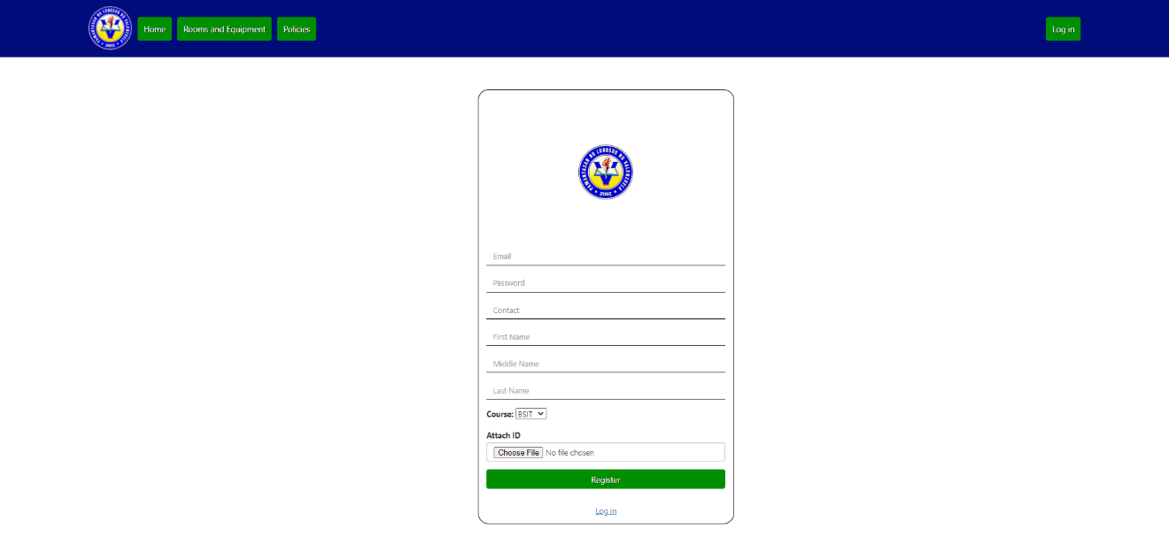

This is the page where new users are able to register an account.

Figure 19.1

Log in Page

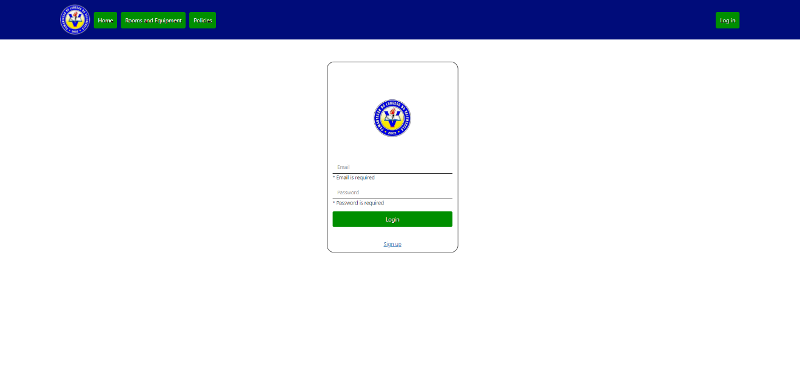

This is the page where verified users are able to log in to the system using their registered account.

Figure 19.2

Polices Page

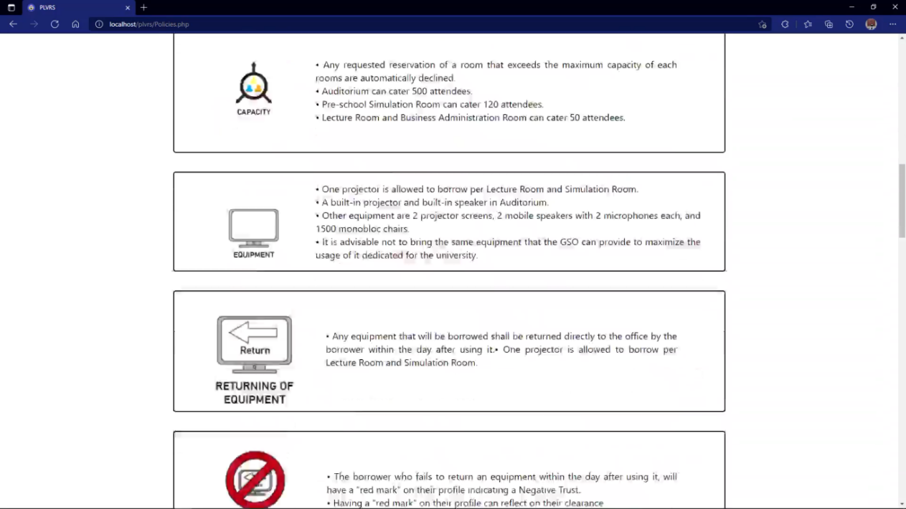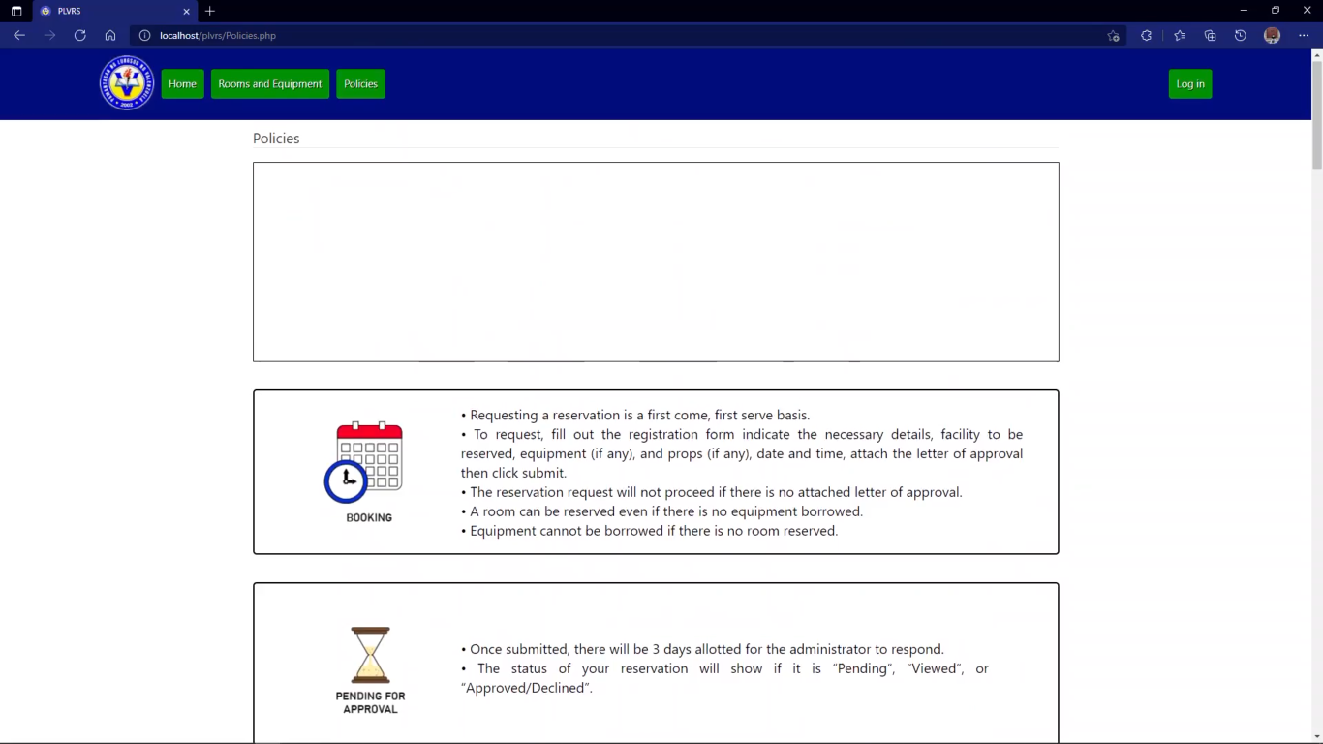

The landing page where users will be able to view first the guidelines and policies in making a reservation of a room and equipment for every log in.

Figure 19.3

User Panel Profile

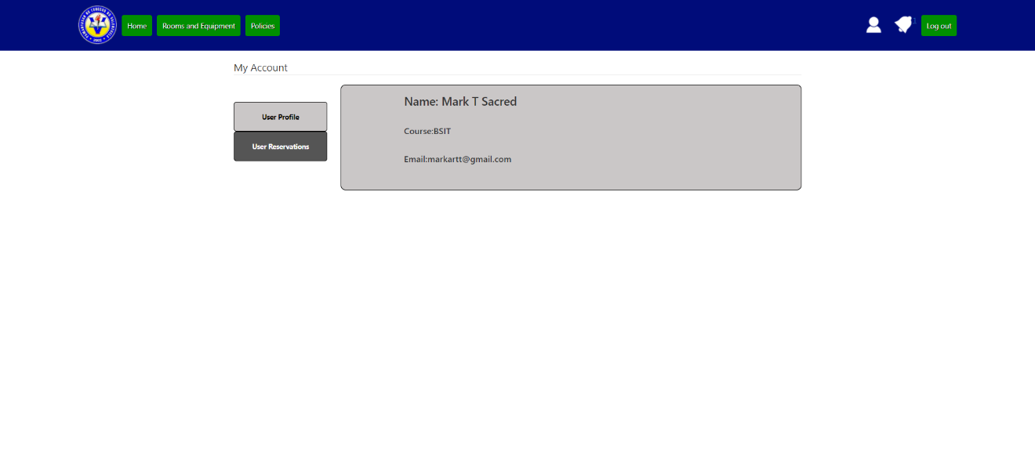

This is the page for users’ profile where they can edit their profile.

Figure 19.4

User Panel Reservations

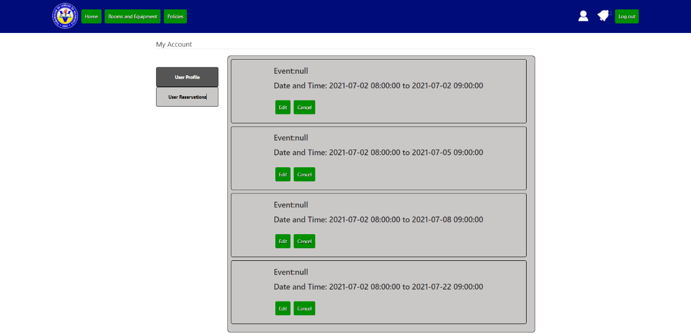

This is the page for users’ profile where they can view their reservations, requested or approved.

Figure 19.5

Admin Panel User Reservations

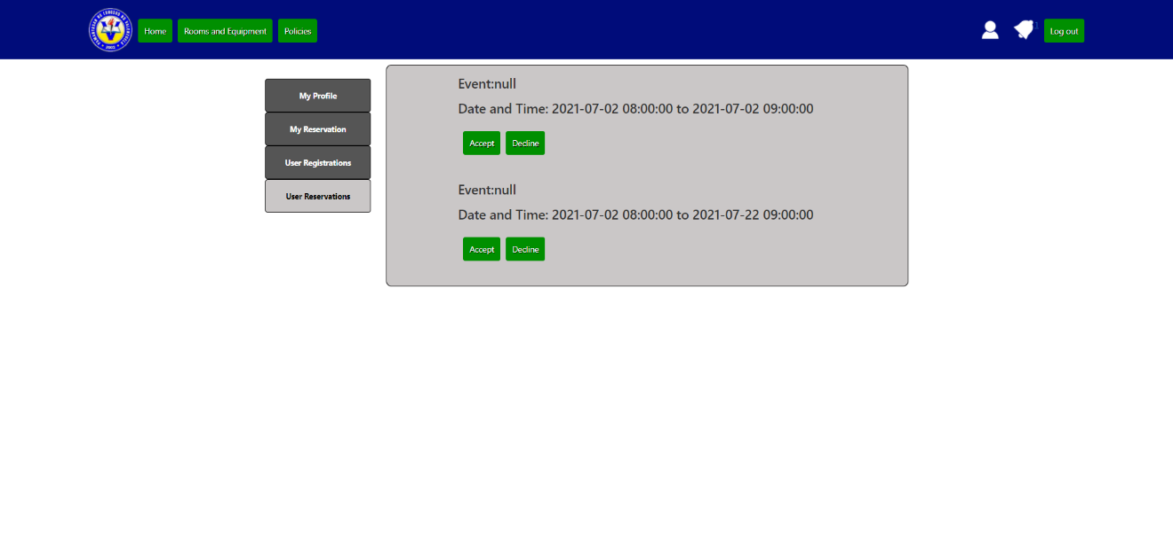

This is the page for administrators only where they can verify the users who wants to create an account.

Figure 19.6

Admin Panel User Registrations

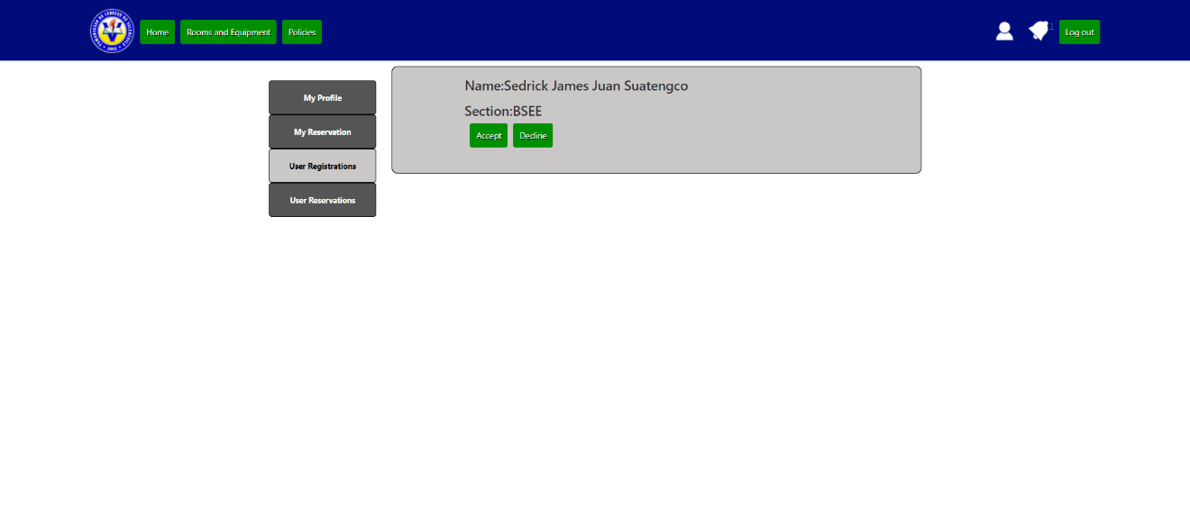

This is the page for administrators only where they can review the reservations requested by the users.

Figure 19.7

Reservation Form

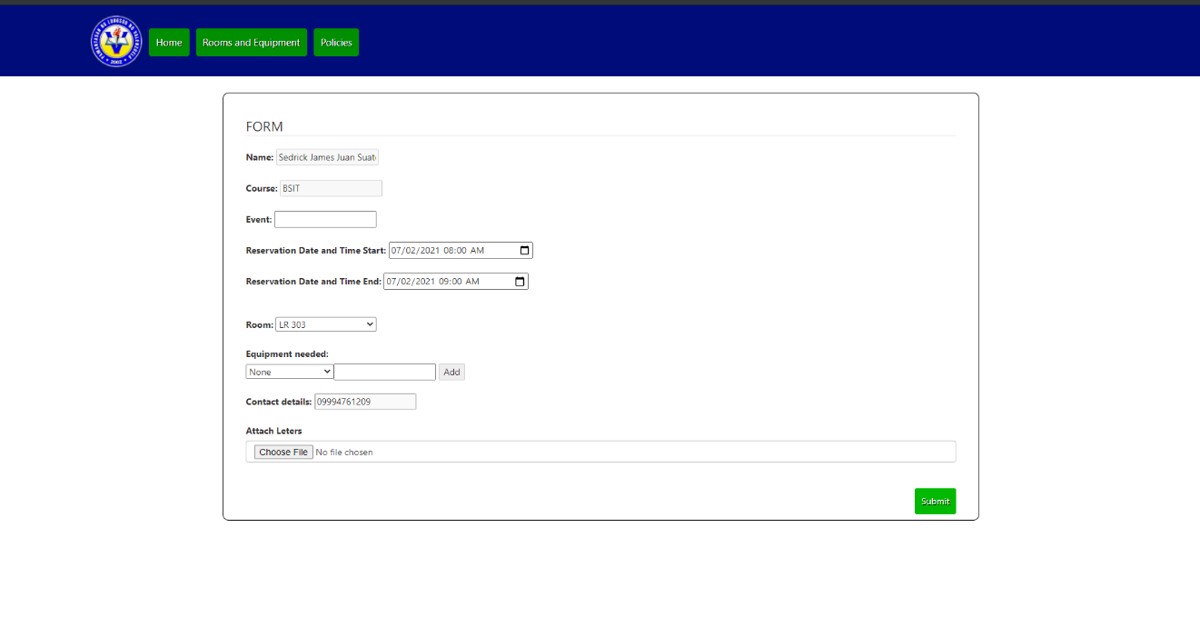

This is the page where users must fill up all the fields shown here to be able to request a reservation.

**3.5 Testing and Evaluation Plan**

There are two types of testing needed for this system to be released, alpha testing and beta testing. Alpha testing is the first testing needed to be done, it ensures that the system will meet the requirements needed and the system itself functions properly, this kind of testing will give the production team the idea that the system is working properly. Alpha testing also ensures the quality of the product. Second testing needed is for this system is beta testing, this is the final testing needed to ensure that the system is ready for public use, this kind of testing will expose all of the remaining bugs and problems of the system.

The standards that will be use for the evaluation of this system is the ISO 9126-1, this is an international standard intended to ensure the quality of all software-intensive products including safety-critical systems where lives are at risk if software components fail. The main criteria and sub criteria are the following:

* Functionality
  + Suitability
  + Security
* Reliability
  + Fault Tolerance
  + Recoverability
* Usability
  + Learnability
  + Operability
* Efficiency
  + Time Behavior
  + Efficiency Compliance
* Maintainability
  + Analyzability
  + Testability
* Portability
  + Adaptability
  + Installability

The first main criteria are the “Functionality” that shows how the system provides the desired functions for the client and its users, under functionality is the “Suitability” that shows if the system can perform the required task, and “Security” that shows if the system can prevent any kinds of malicious activities such as prevent any unauthorized access in to the system. Second criteria are the “Reliability” that shows if the user can rely on the system itself, under that is the “Fault Tolerance” that shows how the system is capable of handling any types of errors, and” Recoverability” that shows how the system will handle lost data and if the system can resume working when the system fails. Third is the “Usability” that shows how well the system can be learned, understood, and used by the user, under it is the “Learnability” that shows how easily will the user understand how the system functions properly, and “Operability” that show how the user easily operates the system itself. Fourth main criteria are the “Efficiency” of the system that shows how well the system provides required performance relative to the number of resources used. Under it is “Time Behavior” that show how quickly does the system respond and “Efficiency Compliance” that shows if the system complies on with the efficiency standard. Fifth criteria are the “Maintainability” that show how well the system can be maintained, under it is “Analyzability” which shows how fast errors and bugs can be analyzed, and “Testability” that show how easily the system can be tested. Last Criteria is the “Portability” that show how the system is portable in other environment, under it is “Adaptability” that’s show how this system can replace other system easily, and “Installability” that shows how easily the system can be installed.

**3.5.1 Entry Criteria**

* The test plan should be approved by the adviser.
* The requirement document for the functional and non-functional requirements are available.
* The testing phase should be approved by the client.
* Software Architecture Diagrams are available.
* Rights for the testers to test the system is established.
* Documented test cases prior from the requirements of the client are available.
* The scope of the system is established.
* The system is fully available to be tested.
* Performance testing of the system must meet the performance requirements of the system.

**3.5.2 Exit Criteria**

* All test cases should be executed.
* No critical / high priority bugs should be left in an open state.
* For low to medium priority bugs, if left in an open state, it should be accepted by the board of panel during the final defense.
* All items in scope were tested.
* The requirement analysis from the client was complied.
* Feedback reports from the bugs are documented.
* All reported bugs must be fixed.

**3.5.3 Schedule**

Table 1

The strategy and testing schedule of the system

|  |  |  |  |
| --- | --- | --- | --- |
| Strategy | Activity | Person Involved | Duration |
| Alpha Test | Preparation | Proponents | 3 Days |
| System testing | Proponents | 1 Day |
| Beta Test | Writing and submission of letter to conduct beta test and evaluation | Proponents  IT Experts  Admin (client) | 7 Days |
| System testing and Evaluation | IT Experts  Target End Users | 7 Days |

**3.5.4 Test Cases**

Table 2

Test Cases of the PLVRS in Connection with the Use Case Diagram

|  |  |  |  |  |  |  |
| --- | --- | --- | --- | --- | --- | --- |
| Test Case ID | Case Name | Description | Test Data | Actual Result | Passed / Failed | Remarks |
| 001 | Input Invalid Email and Valid Password | The user should input wrong email and right password |  |  |  |  |
| 002 | Input Valid Email and Invalid Password | The user should input right email and wrong password |  |  |  |  |
| 003 | Input Invalid Email and Password | The user should input invalid login information |  |  |  |  |
| 004 | Input Valid Email and Password | The user should input valid information |  |  |  |  |
| 005 | Add Room | The user should add room information |  |  |  |  |
| 006 | Add Equipment | The user should add equipment information |  |  |  |  |
| 007 | Update Room | The user should update room information |  |  |  |  |
| 008 | Update Equipment | The user should update equipment information |  |  |  |  |
| 009 | Register Account | The user should register new account |  |  |  |  |
| 010 | View Current Reservations | View all the current reservations created by other user |  |  |  |  |
| 011 | View Past Reservation | View past reservations created by other users |  |  |  |  |
| 012 | Create Reservation | User must create reservation |  |  |  |  |
| 013 | Cancel Reservation | User must cancel reservation |  |  |  |  |
| 014 | Delete Reservation | Admin side must delete reservation |  |  |  |  |
| 015 | Add Damages on Monitoring Form | User must input all the damaged equipment and room in monitoring form |  |  |  |  |
| 016 | Click Login Button | User will click login without inputting any information |  |  |  |  |
| 017 | Click Reservation Button | User will click reservation button without inputting any information |  |  |  |  |
| 018 | Click Add Button (Room) | User will click add button without inputting any information |  |  |  |  |
| 019 | Click Add Button (Equipment) | User will click add button without inputting any information |  |  |  |  |
| 020 | Click Update Button (Room) | User will click update button without inputting any information |  |  |  |  |
| 021 | Click Update Button (Room) | User will click update button without inputting any information |  |  |  |  |

**3.5.5 Evaluation Tool**

Table 3

Equivalent Remarks from the Ratings 1-5

|  |  |
| --- | --- |
| **RATING** | **DESCRIPTION** |
| 5 | Strongly Agree |
| 4 | Agree |
| 3 | Undecided |
| 2 | Disagree |
| 1 | Strongly Disagree |

Table 3.1

Evaluation Questions with regards to the ISO 9126-1

|  |  |  |  |  |  |
| --- | --- | --- | --- | --- | --- |
| **INDICATORS** | **5** | **4** | **3** | **2** | **1** |
| **Functionality** | | | | | |
| **Suitability**  Can the system perform the tasks required? |  |  |  |  |  |
| **Security**  Does the system prevent any unauthorized access? |  |  |  |  |  |
| **Reliability** | | | | | |
| **Fault Tolerance**  Is the system capable of handling any type of errors? |  |  |  |  |  |
| **Recoverability**  Can the system resume working and restore lost data after failure? |  |  |  |  |  |
| **Usability** | | | | | |
| **Learnability**  Can the user learn how to use the system easily? |  |  |  |  |  |
| **Operability**  Can the user operate the system without much effort? |  |  |  |  |  |
| **Efficiency** | | | | | |
| **Time Behavior**  How quickly does the system respond? |  |  |  |  |  |
| **Efficiency Compliance**  Does the system comply with the efficiency standard? |  |  |  |  |  |
| **Maintainability** | | | | | |
| **Analyzability**  Can bugs and errors easily diagnosed? |  |  |  |  |  |
| **Testability**  Can the system be tested easily? |  |  |  |  |  |
| **Portability** | | | | | |
| **Replaceability**  Can the system easily replace other system? |  |  |  |  |  |
| **Installability**  Can the system be installed easily? |  |  |  |  |  |

**3.5.6 Data Categorization**

The answers of IT Experts and End-Users on the level of user acceptability of PLVRS will be classified with the use of the following range of weighted mean and interpretation:

|  |  |
| --- | --- |
| **Range of Weighted Mean** | **Interpretation** |
| 4.51 – 5.00 | Strongly Agree |
| 3.51 – 4.50 | Agree |
| 2.51 – 3.50 | Undecided |
| 1.51 – 2.50 | Disagree |
| 1.50 and below | Strongly Disagree |

**Bibliography**

Anuar, J. et al. (2013) *Smartphone’s Application Adoption Benefits Using Mobile Hotel Reservation System (MHRS) among 3 to 5-star City hotels in Malaysia.* <https://core.ac.uk/download/pdf/82753343.pdf>

Antonelli, W. (2020). *What is Zoom? A Comprehensive Guide to the Wildly Popular Video-Chatting Service for Computers and Smartphones*. Business Insider Nederland. <https://www.businessinsider.nl/what-is-zoom-guide/>

Atkinson, S., & Lee, K. (2018). *Design and Implementation of a Study Room Reservation System: Lessons from a Pilot Program Using Google Calendar | Atkinson | College & Research Libraries*. College & Research Libraries. <https://crl.acrl.org/index.php/crl/article/view/16888/19189>

Belsky, V. (2020). *Web Application vs. Website: Finally Answered*. ScienceSoft. <https://www.scnsoft.com/blog/web-application-vs-website-finally-answered>

College of Education Technology Center. (n.d.). *Spaces*. <https://www.education.uw.edu/technologycenter/spaces/>

ColorWhistle. (2020). *What is Computer Reservation System (CRS) in the Travel Industry?* <https://colorwhistle.com/computer-reservation-system/>

DAS Solutions (2020). *4 Benefits of a Reservation System for Your Hotel*. <https://dassolutions.eu/reservation-system-for-your-hotel/>

DICT. (2020). *Installation of Free WiFi to all Public Schools in Valenzuela*. <https://www.facilitiesbooking.com/About-Us/Blog/ArticleID/10/Unique-Benefits-Of-A-Room-Resource-Booking-System-For-Schools>

Domantas, G. (2020). *What is Web Hosting? Web Hosting Explained for Beginners*. Hostinger Tutorials. <https://www.hostinger.ph/tutorials/what-is-web-hosting/>

Ecobook. (n.d.). *Unique Benefits of a Room & Resource Booking System for Schools.* <https://www.facilitiesbooking.com/About-Us/Blog/ArticleID/10/Unique-Benefits-Of-A-Room-Resource-Booking-System-For-Schools>

Essential Designs. (2019). *Website vs Web App: What’s the Difference? - Essential Designs*. Medium. <https://medium.com/@essentialdesign/website-vs-web-app-whats-the-difference-e499b18b60b4>

Facebook. (n.d.). *How do I finish creating my Facebook account and confirm my email or mobile phone number?*   
<https://m.facebook.com/help/223900927622502>

Gungon, R. (2021). *What is an online reservation system and why you should use*. Omnify. <https://www.getomnify.com/blog/one-reservation-system>

Henry, C. (2018). *Qualitative Study of Online Hotel Booking System.* <https://pmworldlibrary.net/wp-content/uploads/2018/03/pmwj68-Mar2018-Henry-study-of-online-booking-systems-student-paper.pdf>

*Hotel Reservation System for Hotel Selena*. (2020). <http://docshare02.docshare.tips/files/8278/82783766.pdf>

LRS Web Solutions. (2018). *11 Best Practices for Secure Web Applications*. <https://www.lrswebsolutions.com/Blog/Posts/32/Learn-More/2018/11/11-Best-Practices-for-Developing-Secure-Web-Applications/blog-post/>

Molinillo, S., & Japutra, A. (2017, May 8). *Organizational adoption of digital information and technology: A theoretical review*. Emerald Insight. <https://www.emerald.com/insight/content/doi/10.1108/BL-01-2017-0002/full/html>

Parker Software (2019). *Web vs desktop apps: a weigh-up*. <https://www.parkersoftware.com/blog/web-vs-desktop-apps-a-weigh-up/>

Powell, R. (2018). *Benefits of online booking vs. offline booking*. Cultus. <https://www.onlinecultus.com/2018/10/16/benefits-of-online-booking-vs-offline-booking/>

SiteMinder. (2020). *Why is a reservation system so important for your hotel?* [https://www.siteminder.com/r/technology/hotel-cloud-technology/why-reservation-system-important-hotel/.](https://www.siteminder.com/r/technology/hotel-cloud-technology/why-reservation-system-important-hotel/)

Steeves, K. (2020). *What Exactly is an Online Booking System?* Checkfront. <https://www.checkfront.com/what-is-an-online-booking-system>

Stevens, E. (2018). *What is the Difference Between a Mobile App and a Web App?* CAREERFOUNDRY. <https://careerfoundry.com/en/blog/web-development/what-is-the-difference-between-a-mobile-app-and-a-web-app/>

Summerfield, J. (n.d.). *For Broad Marketing Outreach, A Mobile Website is the Place to Start.* Human Service Solutions. <https://www.hswsolutions.com/services/mobile-web-development/mobile-website-vs-apps/>

Travelpro. (2019). Airline CRS | Airline CRS Systems | CRS System. https://www.travelopro.com/airline-crs.php

Tyrocity. (2019). *Importance of record management | Management Notes | TyroCity*. <https://tyrocity.com/topic/importance-of-record-management/>

Velocity Consultancy. (2018). *10 Elements Every Website Should Have to Attract Website Visitors*. <https://www.velocityconsultancy.com/elements-every-website-should-have/>

Vents, V. (2019). *3 Reasons Why Hosting is Important for Your Website*. Whimsie Creative Agency. <https://whimsiecreative.co.uk/3-reasons-why-hosting-is-important-for-your-website/>

Williams, K., & Micheal, A. (2018). *Design and Implementation of Reservation Management System Case Study: Grand Ville Hotels*. Longdom. <https://www.longdom.org/open-access/design-and-implementation-of-reservation-management-system-case-study-grand-ville-hotels.pdf>

YArooms. (2020). *Workplace scheduling software*. <https://www.yarooms.com/?gclid=capterra-scheduling&utm_source=GetApp&fbclid=IwAR0_3i8Jg-5zFzWz6Wvxy8pg86sw0EsZ7uAxAvMCDHC7WoCC9d7YSzA8C0I>

**Initial Guidelines and Policies of Room and Equipment Reservation**

|  |  |  |
| --- | --- | --- |
| **GUIDELINES AND POLICIES OF ROOM AND EQUIPMENT RESERVATION** | | |
|  | **OLD** | **NEW** |
| **Booking** | Booking of room and equipment is on a first-come, first-serve basis. There is no prioritization of any events and persons that are making a reservation. To request, the user must personally visit the GSO to ask for a reservation on a specific date and time, he/she must present the letter of approval for the event that is going to occur. If there is no letter of approval presented, the request for the reservation will not proceed. There will be a reservation form given to the user for the GSO to record the reservation made. A short interview is done to verify the user, know the purpose of reserving, the number of attendees, and discuss the policies to the reserved room and equipment. All reservation request is going to be approved by the GSO. Afterward, the user must photocopy the letter of approval signed by the GSO for both sides to have a copy and give it to the GSO. To borrow equipment, the user must present their ID for verification. Booking of equipment is optional if the user needs it. Therefore, allowing a room to be reserved even if there is no equipment borrowed. But, borrowing only equipment is prohibited. | Booking of room and equipment is on a first-come, first-serve basis. There is no prioritization of any event and persons that are making a reservation. To request, the user can request the reservation using PLVRS. All reservation requests are going to be approved by the GSO and must be requested electronically. Not over the phone, not personally. The user can fill out the registration form indicating the name, contact number, course, department, event, number of expected attendees, facility to be reserved, equipment (if any), and props (if any), specify the date and time, and must have a soft copy of the letter of approval to be attached to the reservation page then click submit. If there is no attached letter of approval, the request to submit will not proceed. Booking of equipment is optional if the user needs it. Therefore, allowing a room to be reserved even if there is no equipment borrowed. But, borrowing only equipment is prohibited. |
| **Approval of Request** | The approval of reservation will usually take a 1-day review depending on the availability and presence of the person-in-charge in their office. | Once the request was submitted, there will be 3 days allotted for the GSO to respond. The progress will show “Pending” if the request is still waiting for review, “Viewed” if the GSO open and currently reviewing the request, and lastly the verdict if the request is approved or declined. |
| **Minimum Days of Booking** | Minimum of 3 days before the event should request for a reservation for it to be approved. The requests that will be made lesser than 3 days will surely make it difficult for the GSO to review the reservations because of the room and equipment availability and maintenance. | Minimum of 3 days before the event should request for a reservation for it to be approved. Users that request reservations lesser than 3 days will automatically be denied. |
| **Rooms** | Rooms under the jurisdiction of GSO are Lecture Room 301, 302, 303, 401, 402, and 403. Pre-school Simulation Room, Business Administration Simulation Room, and Auditorium. The Auditorium can only have 1 reservation per day. | Rooms under the jurisdiction of GSO are Lecture Room 301, 302, 303, 401, 402, and 403. Pre-school Simulation Room, Business Administration Simulation Room, and Auditorium. The Auditorium can only have 1 reservation per day. |
| **Capacity** | The capacity of each room will be negotiated upon the interview of requesting a reservation. Auditorium can cater 500 attendees, 120 for Pre-School Simulation Room, 50 for all Lecture Rooms as well as the Business Administration Simulation Room. | Any requested reservation of a room that exceeds the maximum capacity of each room is automatically declined. Auditorium can cater 500 attendees, 120 for Pre-school Simulation Room, 50 for all Lecture Rooms as well as the Business Administration Room. |
| **Equipment** | One projector is allowed to borrow per Lecture Room and Simulation Room. There is a built-in projector and built-in speaker in Auditorium. Other equipments are 2 projector screens, 2 mobile speakers with 2 microphones each, and 1500 monoblock chairs. The GSO advises not to bring the equipment that they can already provide to maximize the usage of it dedicated for the university. | One projector is allowed to borrow per Lecture Room and Simulation Room. There is a built-in projector and built-in speaker in Auditorium. Other equipment are 2 projector screens, 2 mobile speakers with 2 microphones each, and 1500 monoblock chairs. It is advisable not to bring the same equipment that the GSO can provide to maximize the usage of it dedicated for the university. |
| **Returning of Equipment** | Any equipment that will be borrowed shall be returned directly to the office by the user within the day after using it. | Any equipment that will be borrowed shall be returned directly to the office by the user within the day after using it. |
| **Fail of Returning an Equipment** | The person in charge will not give a warning or penalty to the user. | The user who fails to return a piece of equipment within the day after using it will have a “red mark” on the profile indicating that the user has a history of negligence. Having a “mark” on the user’s profile can reflect on their clearance. |
| **Inventory** | The inventory of equipment is checked every after reservation. No recorded data or report will be made. | The number of rooms and equipment, as well as its availability, is recorded in the system for reliable monitoring. There will be a monitoring sheet and inventory report generated every after reservation. Its content will depend on the reservation details and will automatically update the availability of room and equipment once the request for the reservation is submitted. In case it coincides with broken equipment or is needed within the next reservation, the system will automatically notify the user who will be affected. |
| **Damages** | Users agreed not to damage the room and equipment reserved upon the interview. If equipment is severely damaged, it will be replaced with the same specification. But, if the equipment is lightly damaged, the Local Government Unit (LGU) will be responsible for it. Affixing items to the walls, floors, ceilings of any room, taping, or nailing items to any surface is prohibited. The user who damaged the item will be contacted by the GSO and must personally go to their office. | Verified users agree not to damage the room and equipment reserved. If equipment is severely damaged, it will be replaced with the same specification. But, if the equipment is lightly damaged, the Local Government Unit (LGU) will be responsible for it. Affixing items to the walls, floor, ceilings of any room, taping, or nailing items to any surface is prohibited. The user who damaged the item will be contacted by the GSO and must personally go to their office. |
| **Props and Other Materials** | Upon interview when requesting a reservation, the usage of props will be asked and evaluated. If there is any, the inspection will take place on the reserved date to know the actual appearance of it. | If any props are going to be used, it will be indicated in the reservation form including the size, quantity, description, and image before submitting the request to inform the GSO. |
| **Requestor** | GSO will cater to students, professors, and PLV admin personnel. | GSO will cater to students, professors, and PLV admin personnel. |
| **Prioritization** | First come, first serve basis whether the requestor is a professor or a student and whatever the purpose of the event. | First come, first serve basis whether the requestor is a professor or a student and whatever the purpose of the event. |
| **Invalid Request** | If the user requests a room that is not under the jurisdiction of GSO, he/she will be sent to the Registrar Office. | The user will not locate the rooms that are not under the jurisdiction of GSO because of the lists of available rooms provided in the system upon requesting a reservation. |
| **Follow-ups** | The user needs to personally go to the office of GSO. The user can also contact the GSO via telephone. The follow-up will be catered immediately depending on the availability and presence of the GSO in their office. | The reservation request must be 3 days before the event. The user can send a follow-up using “submit a ticket” in the system. The GSO will be notified via PLVRS and email notification. Also, the requestor will have proper documentation of the follow-up ticket to be sent on their email to inform them that the follow-up was sent. The status of the request will be shown again to the user’s reservation progress. |
| **Rescheduling** | To reschedule, the requestor must personally go to the GSO and present a new letter of approval signed by the respected authorities indicating the new date and time of the event. A short interview will occur to know the reason for rescheduling. | The user can reschedule the request for reservation whether it is approved or pending. The only requirement for rescheduling is the same letter of approval with the rescheduled date that is signed by the respected authorities will be used. The requestor must input the reason for rescheduling to the rescheduling page. Once submitted, the GSO will review the request. |
| **Canceling** | The requestor can cancel their reservation a minimum of 1 day before the reserved date by personally going to the GSO. But there are scenarios wherein the requestor wants to cancel their reservation on the same day. The GSO will then interview again the requestor for the reason of cancellation and erase the scheduled reservation on the whiteboard. | The requestor can only and automatically cancel their reservation a minimum of 1 day before the reserved date whether the status of their request is pending or approved. The GSO will be notified that the reservation was canceled and will mark on the monitoring list as “canceled”. |
| **Notifying** | The GSO is not notified of any pending, approved, rescheduled, and canceled reservation. | The GSO will be notified via PLVRS and email notification about the pending requests, approved/declined requests, rescheduled, and canceled reservations. |
| **Contacting** | The GSO can be contacted using their telephone number and personally going to their office. | The GSO can be contacted using the messaging provided in PLVRS, email, and telephone number. |
| **Food and Beverages** | The policy of bringing food and beverages will be informed to the users upon interviewing. Food and Beverages are strictly not allowed in the Auditorium and Simulation Rooms. | The policy of bringing food and beverages will be located on the home page of PLVRS to be informed immediately upon logging in. |



Approved by:

**Engr. PSALMS JUNE H. TAN**

*Assistant Building Administrator*

**Wireframe**

**PC/Tablet view**  
Room and equipment – Admin view

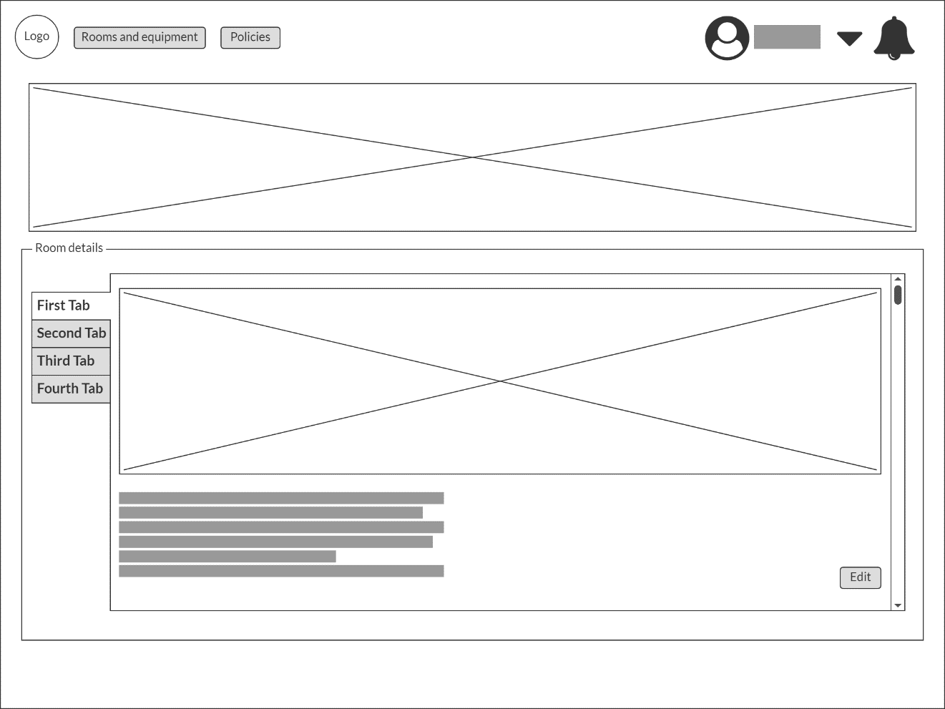

User view

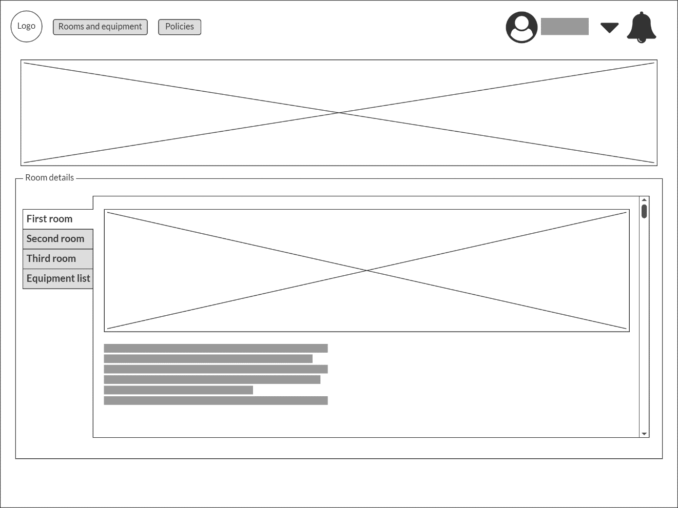

Main page

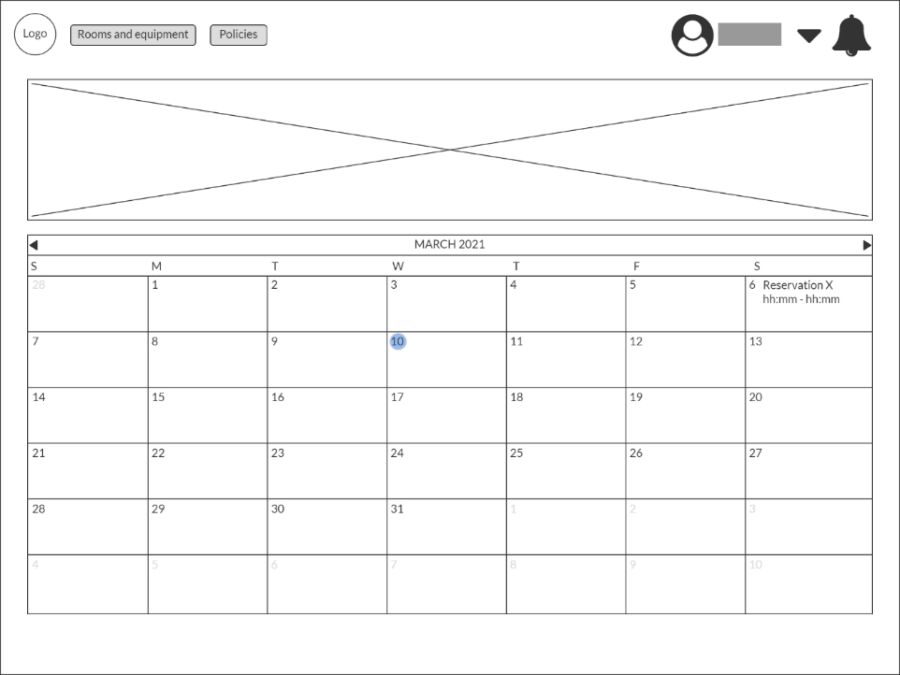

Login page

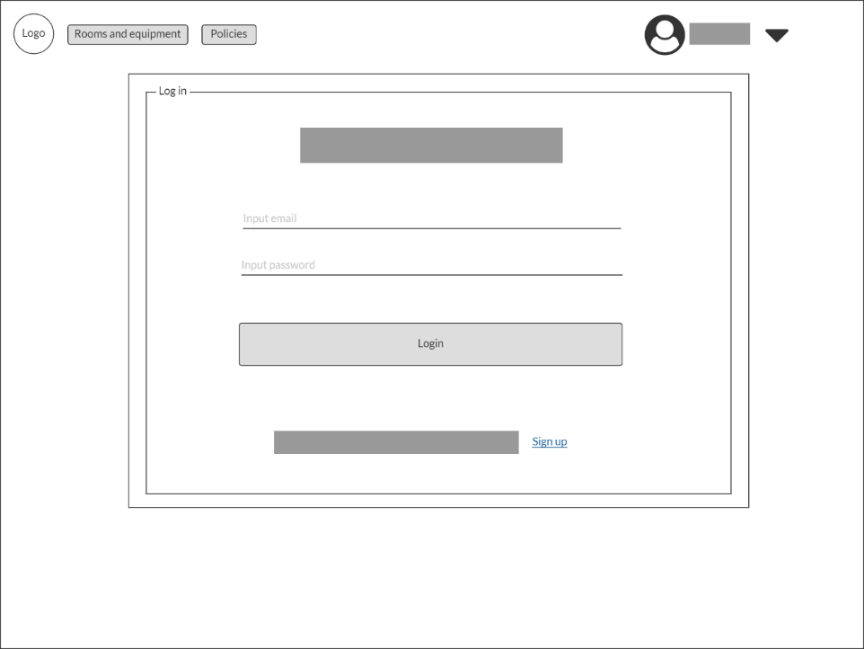

Registration page

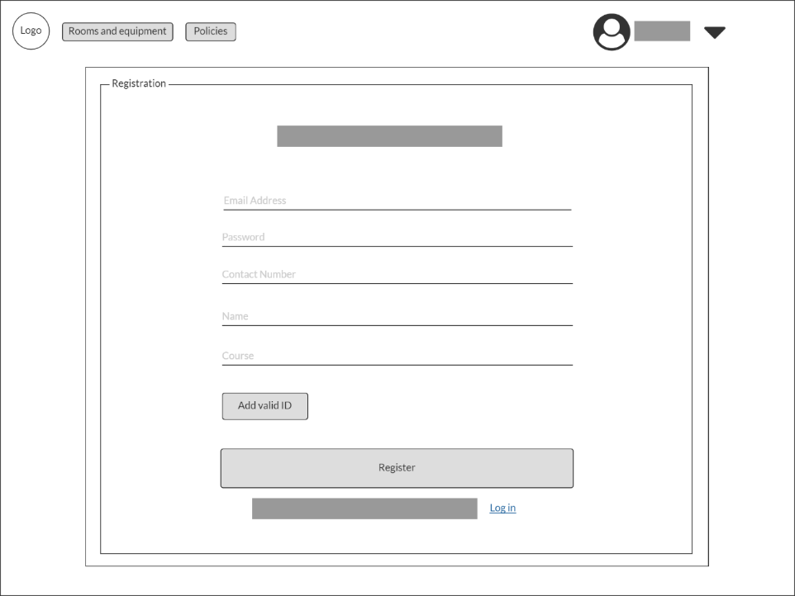

Select date page – Admin view

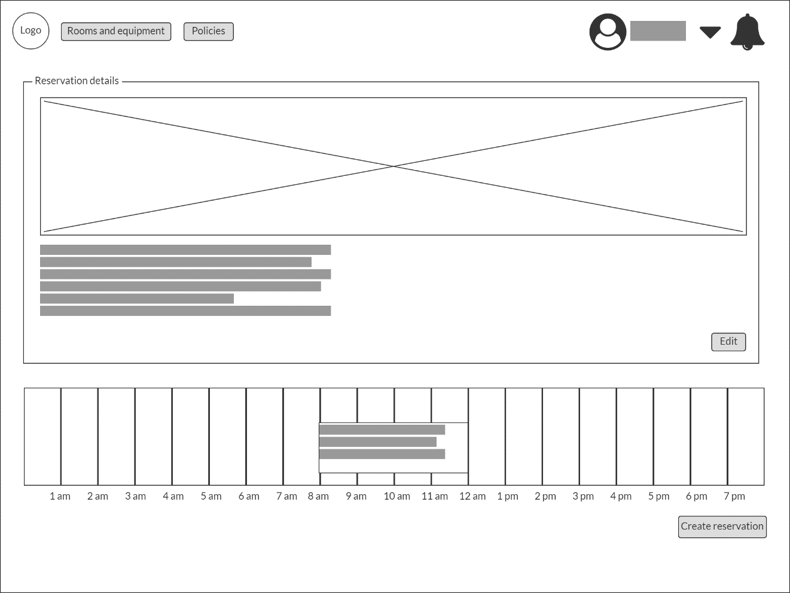

User view

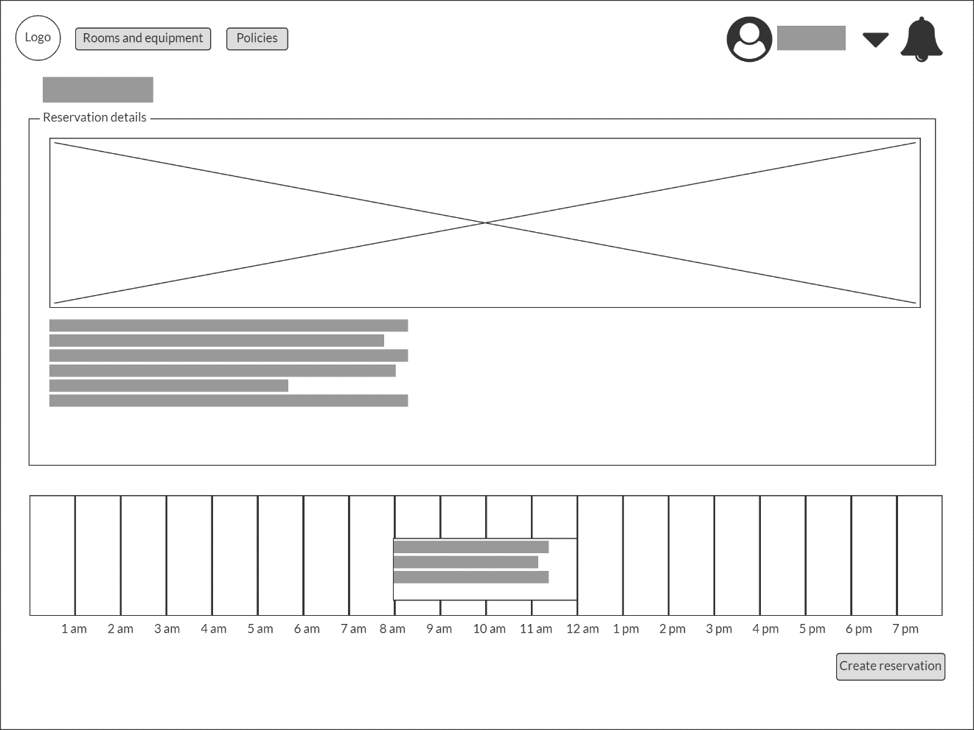

Create reservation page

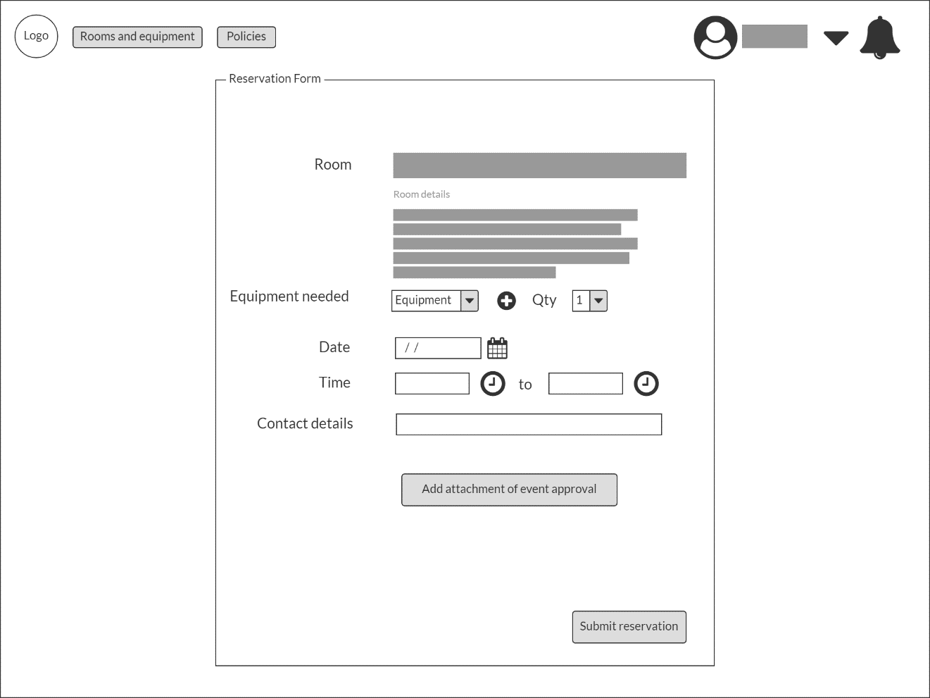

Policies page – Admin view

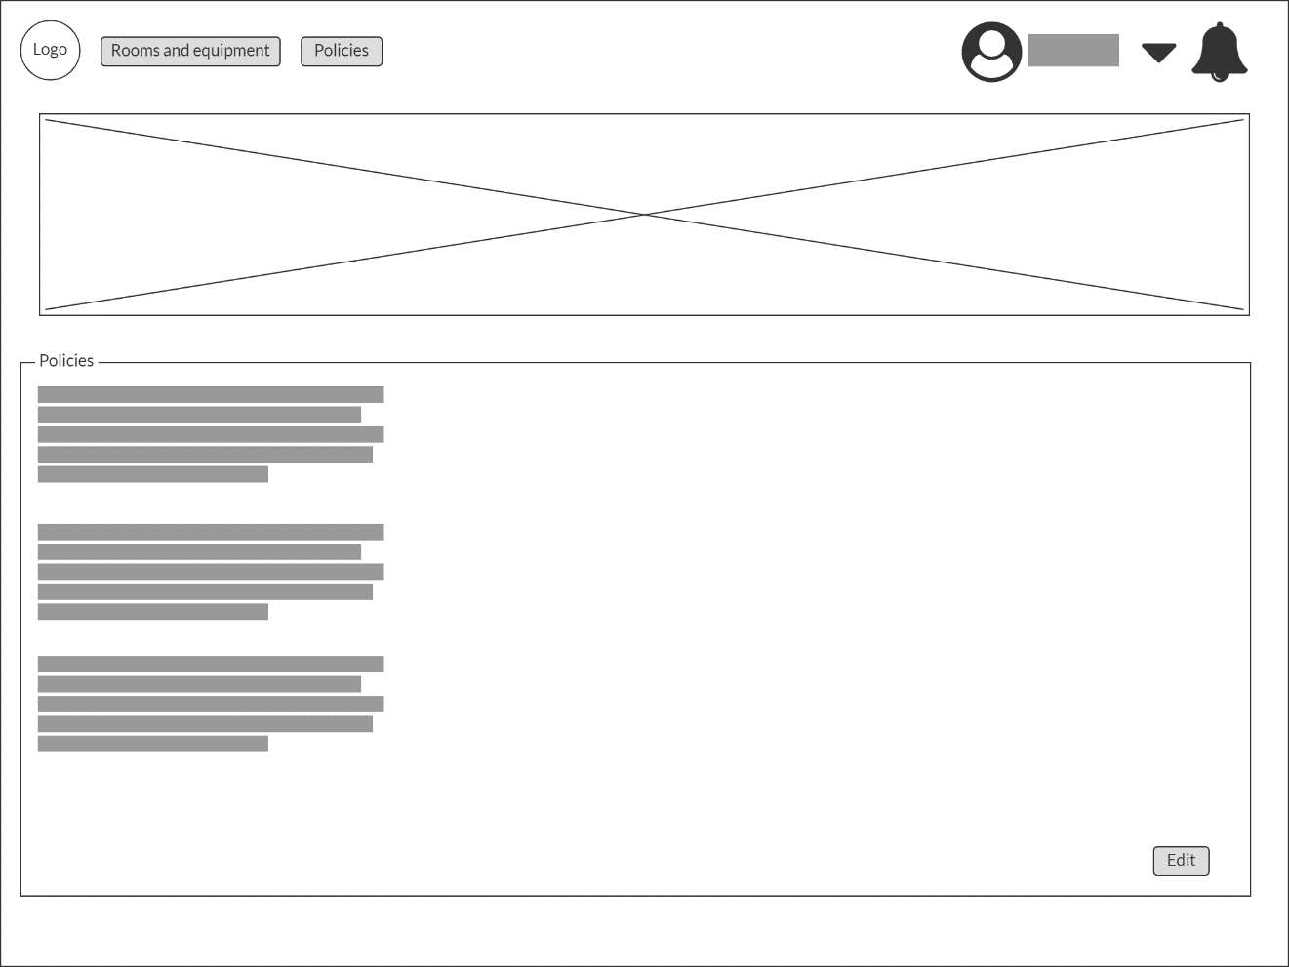

User view

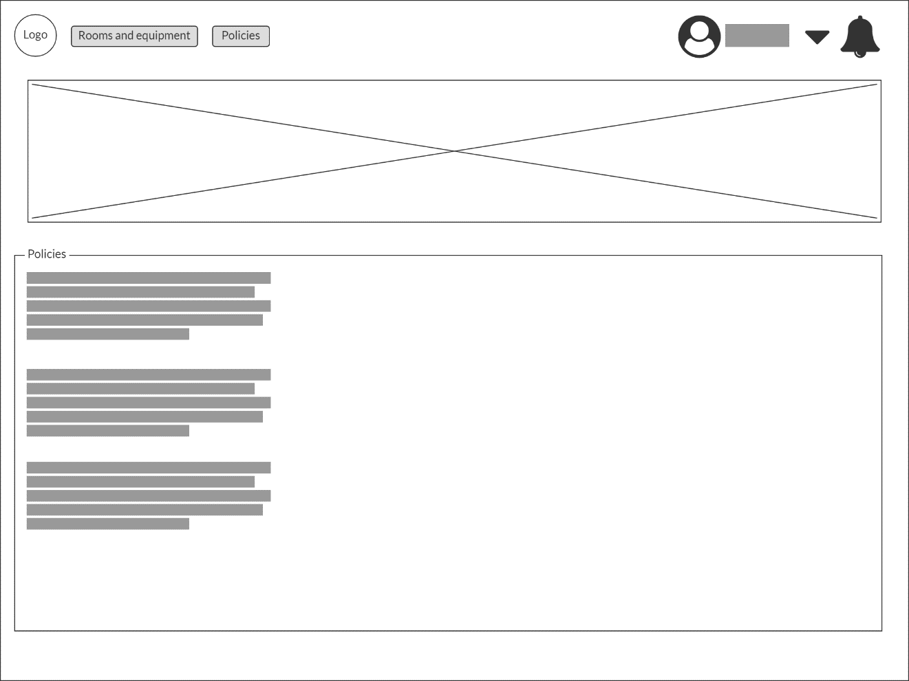

Profile page – User details/My profile

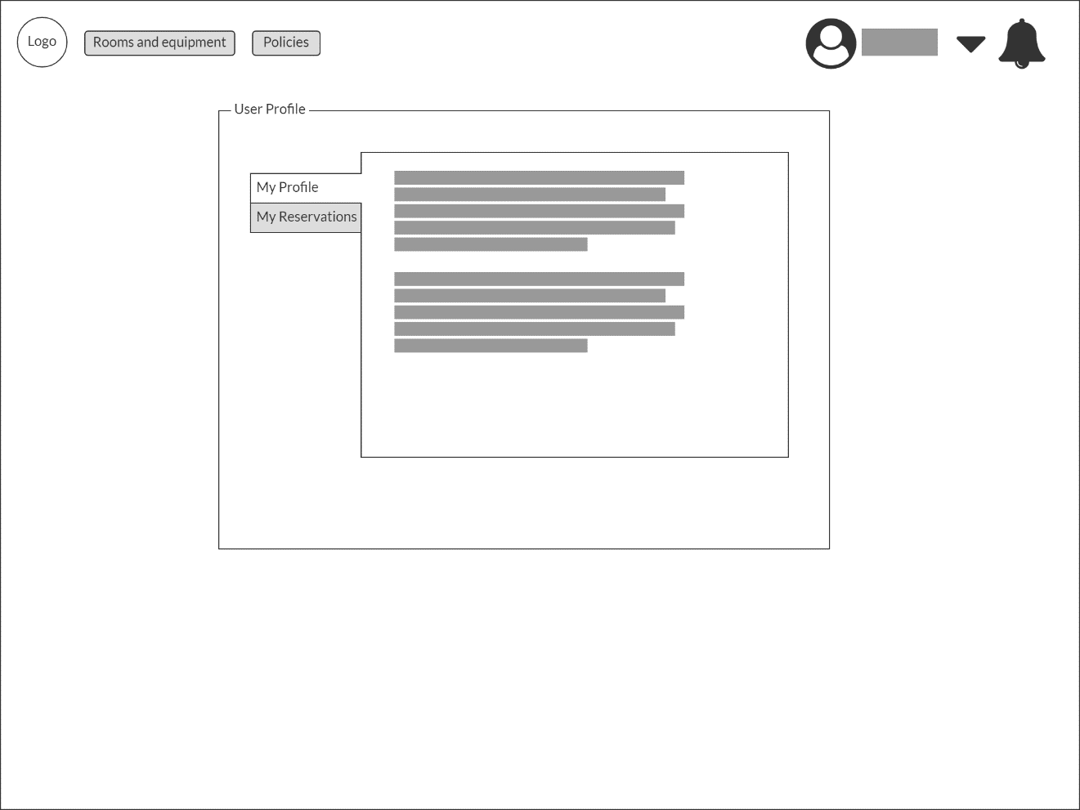

Profile page – Reservation page

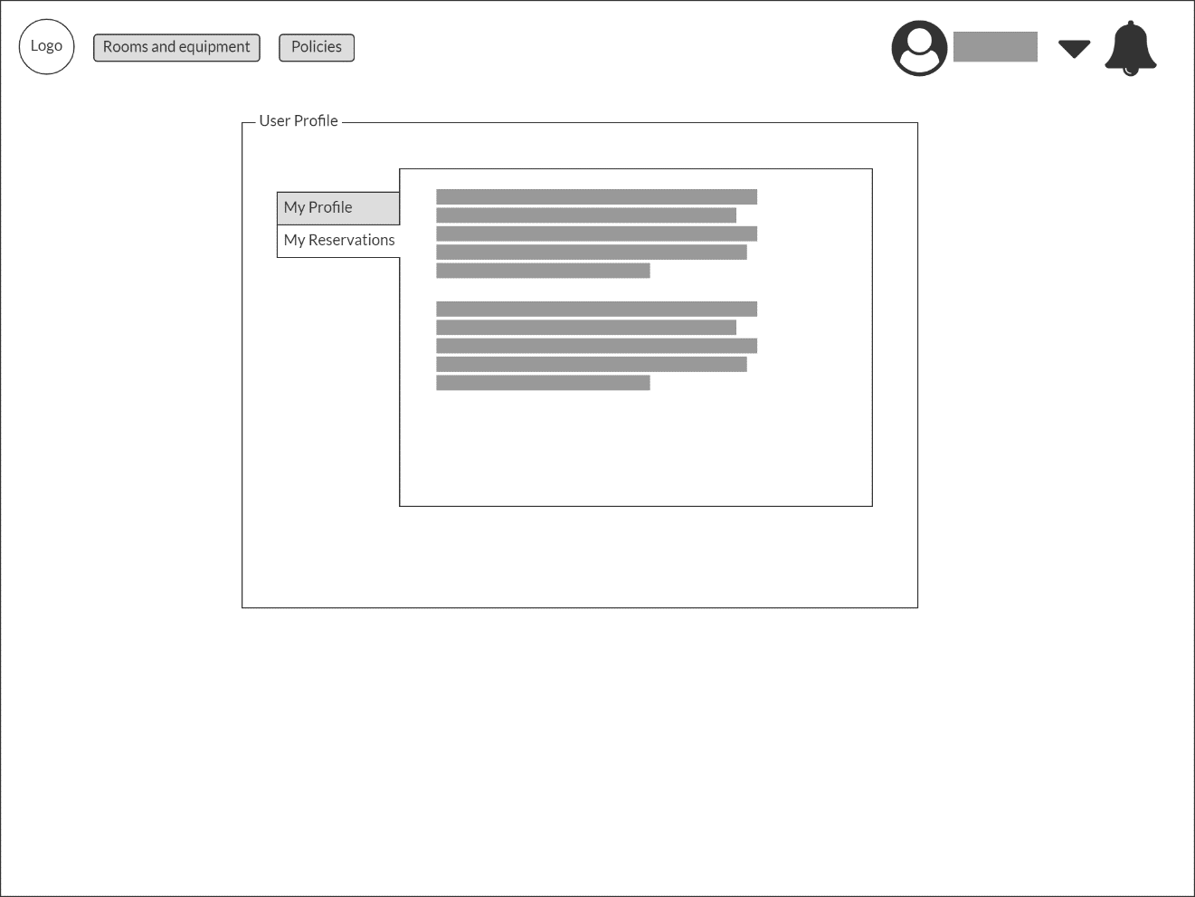

Admin – User registration

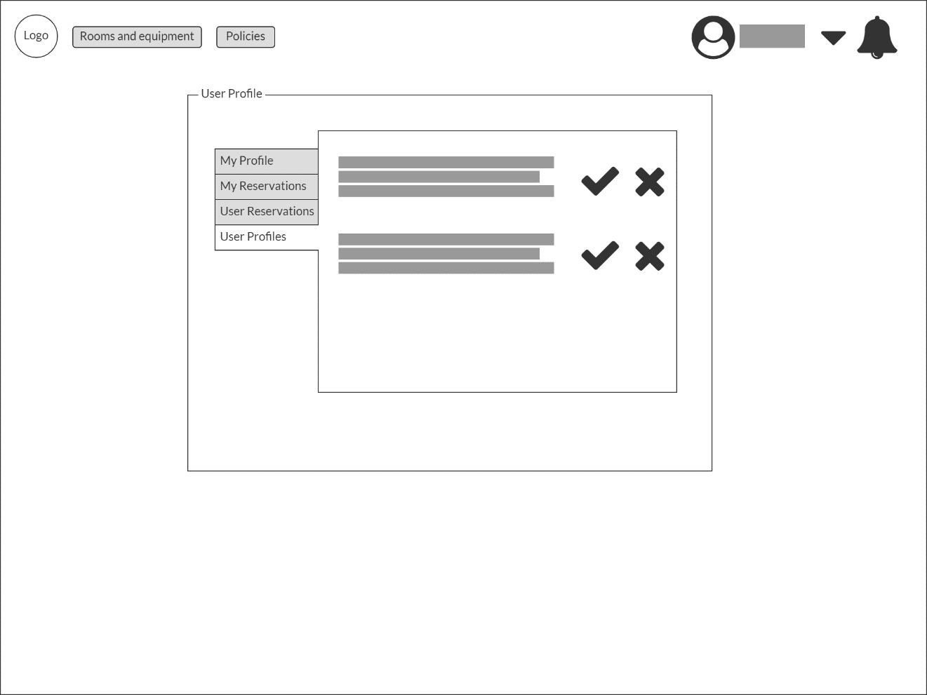

User reservation

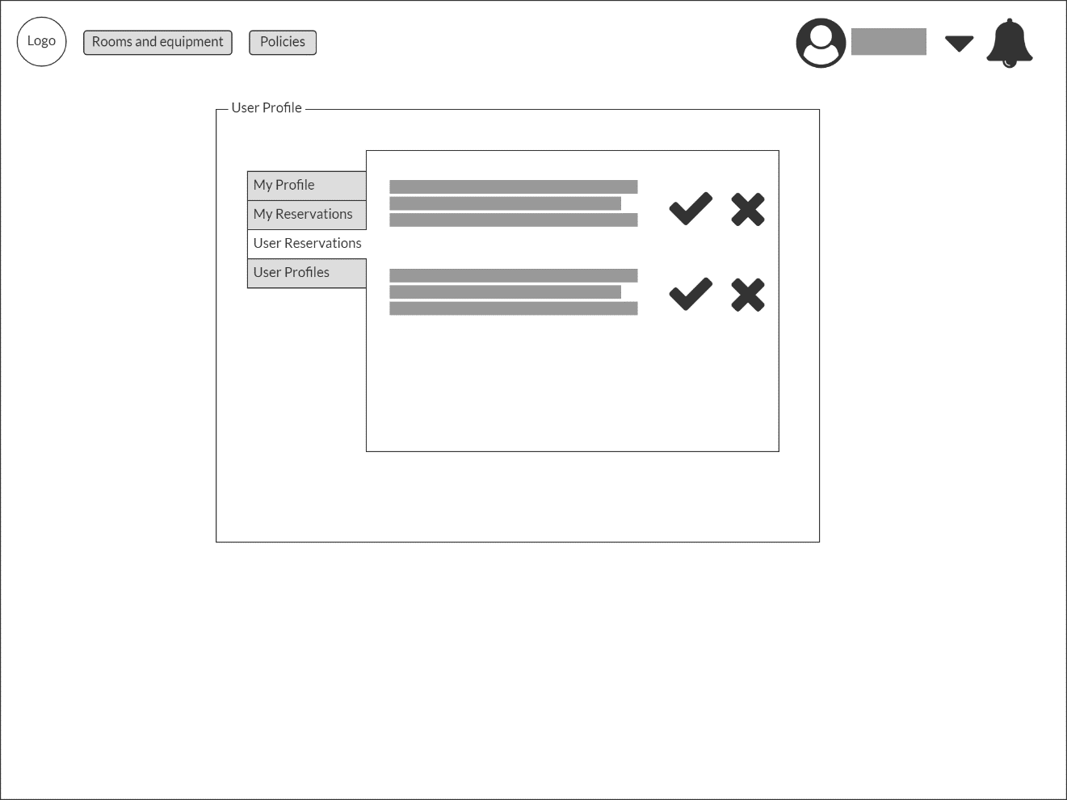

Monitoring page

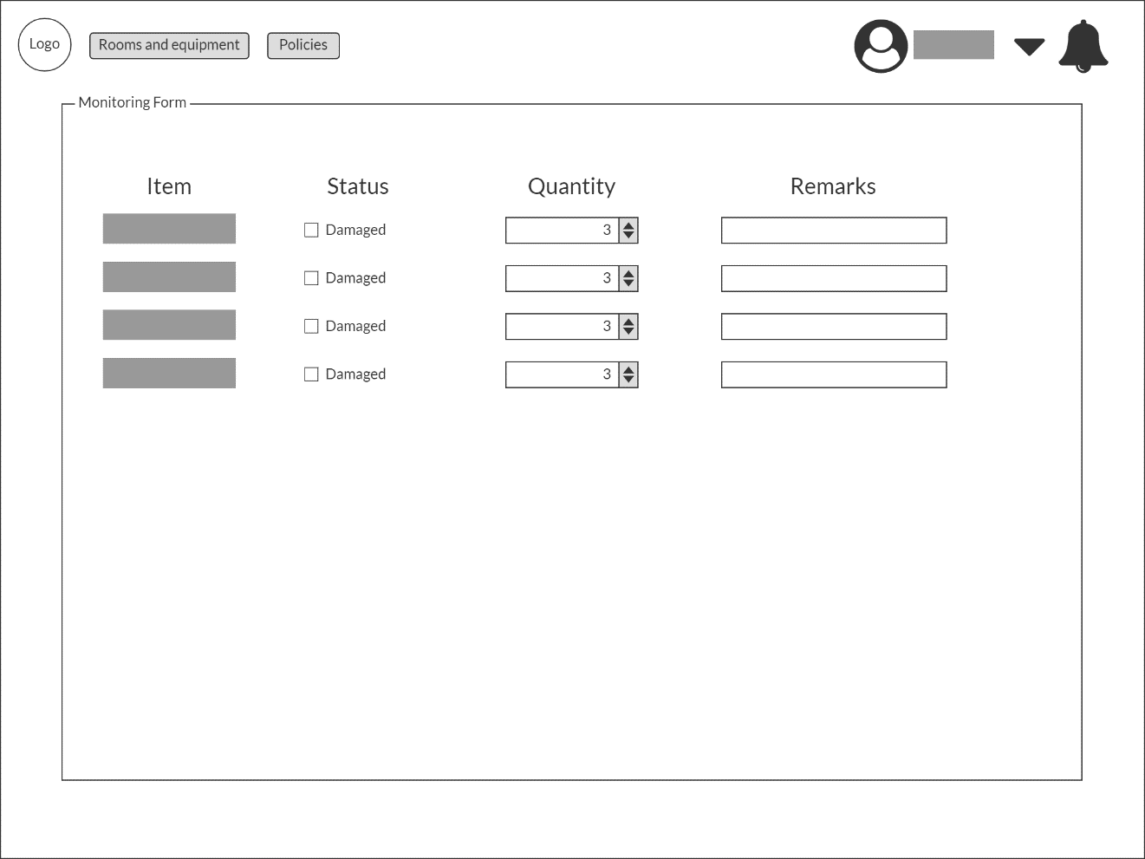

**Mobile view**

Room and equipment – Admin view User View

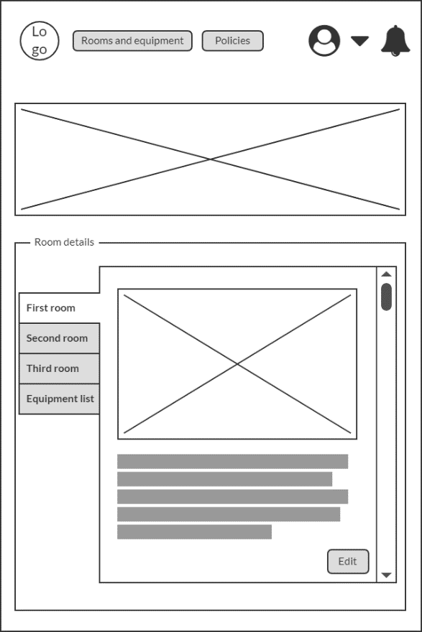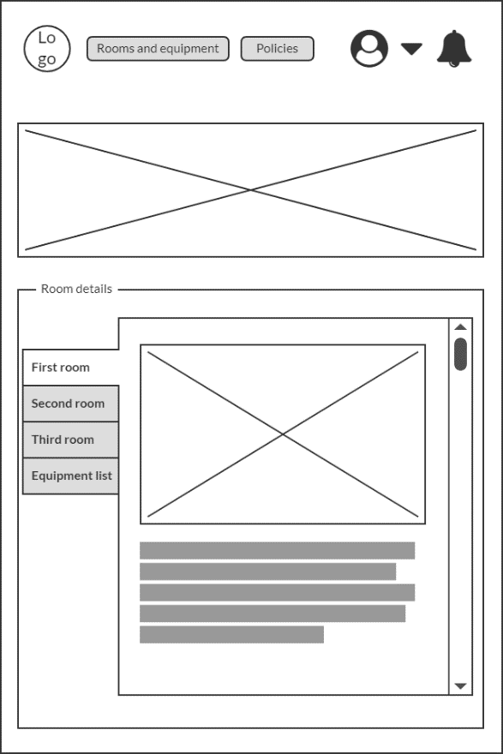

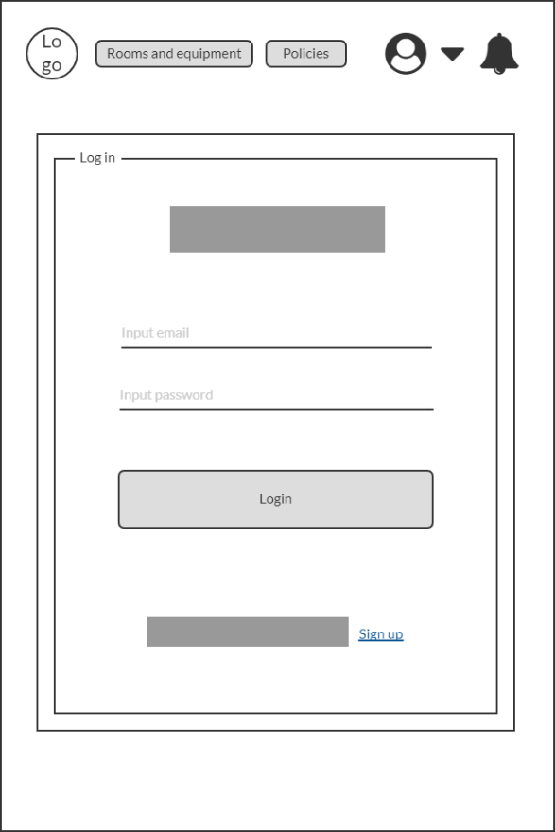Main Page Login Page

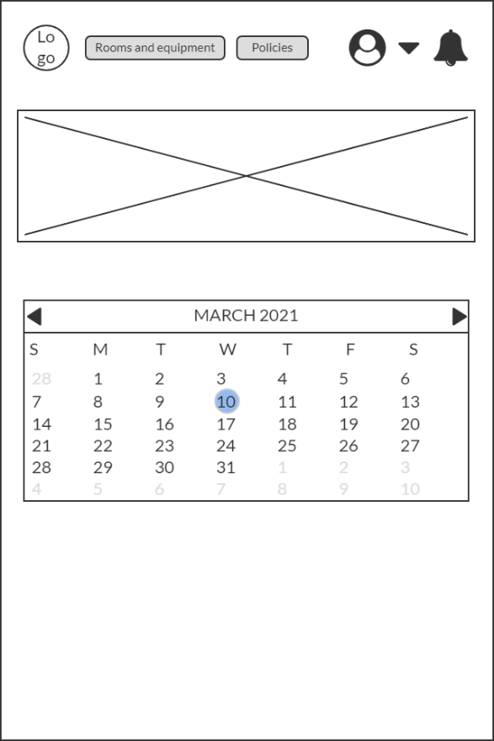

Registration Page Select Date – Admin View

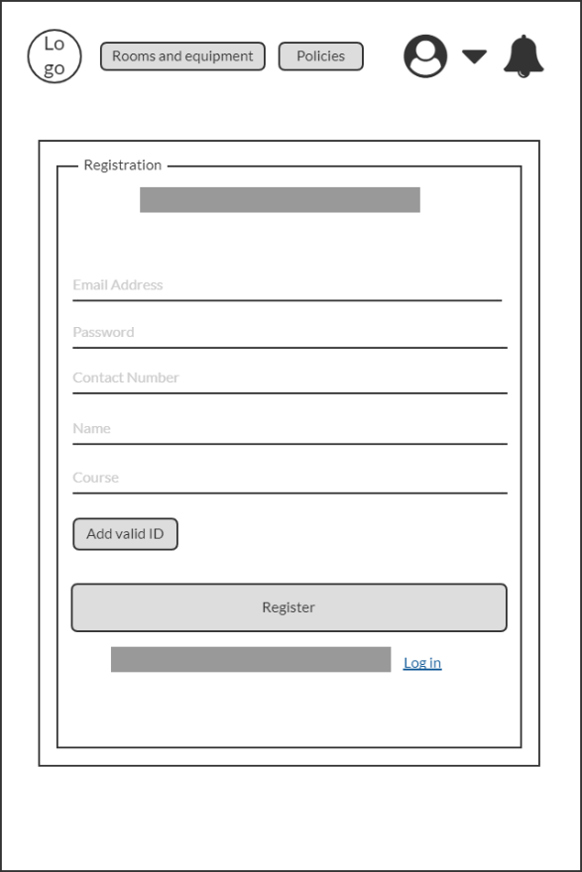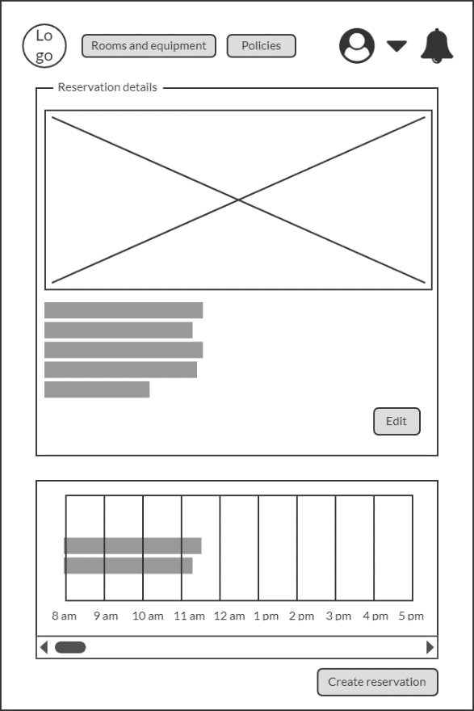

Select Date - User View Create Reservation Page

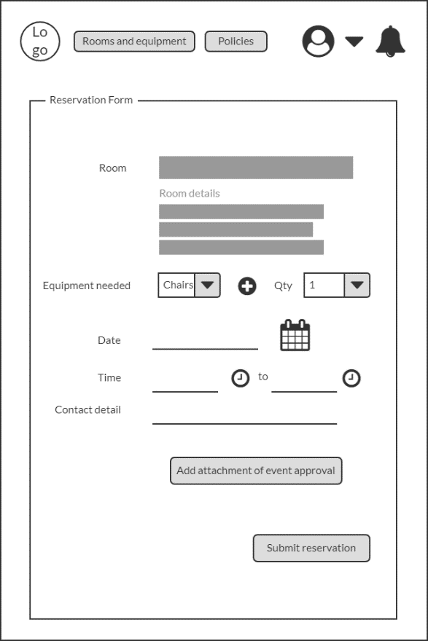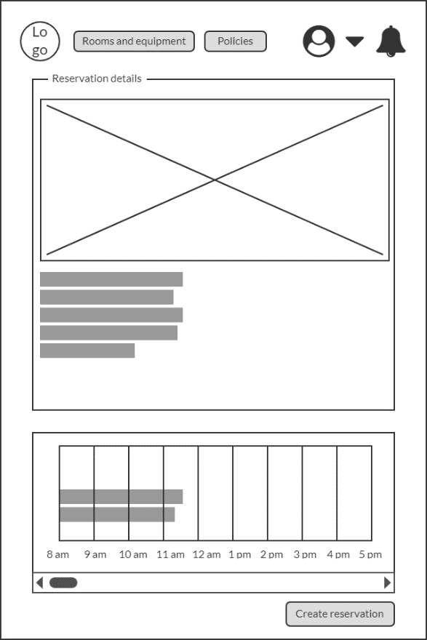

Polices Page – Admin view Policies Page – User View

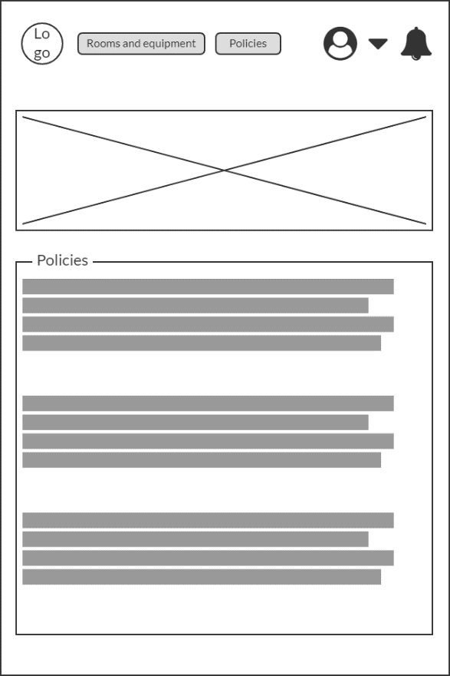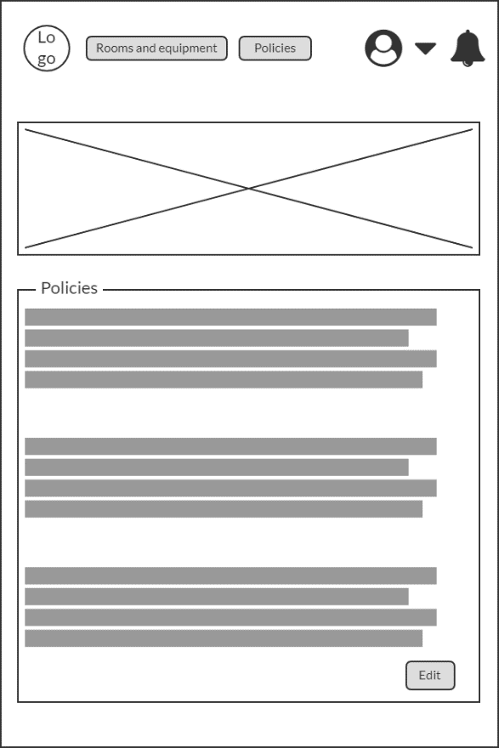

Profile Page – User details/My profile Profile Page – Reservation page

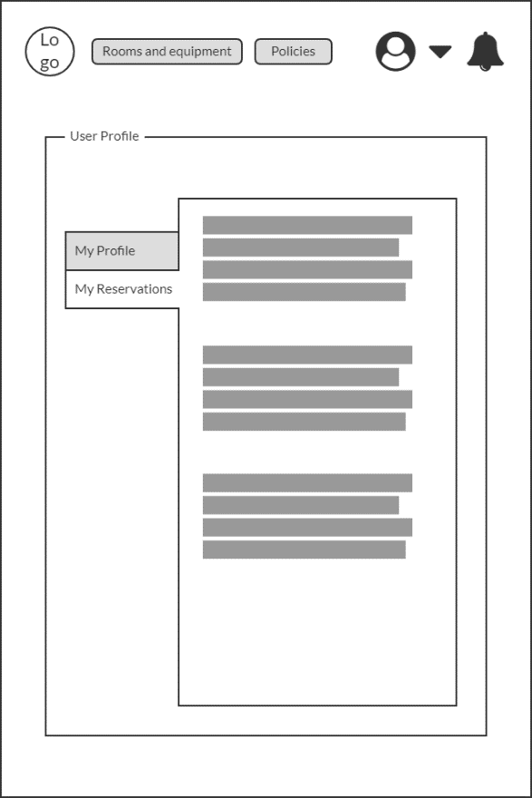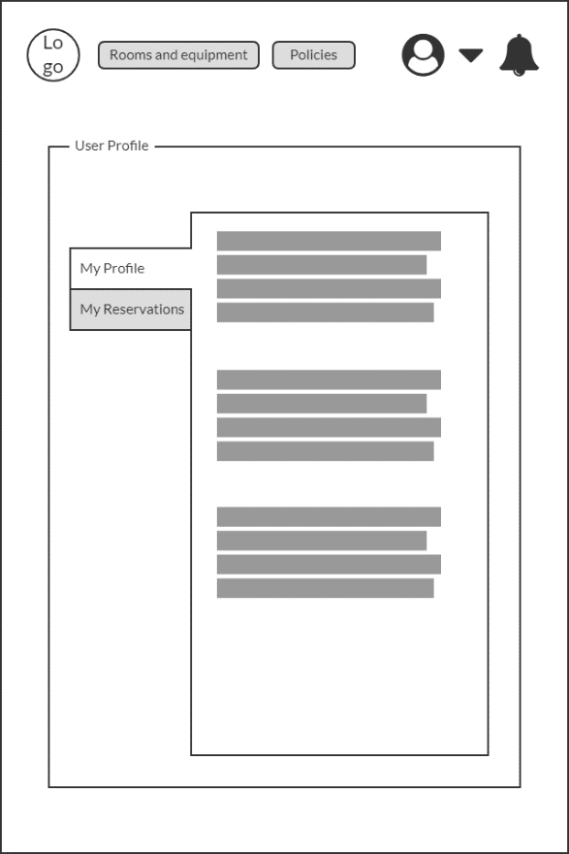

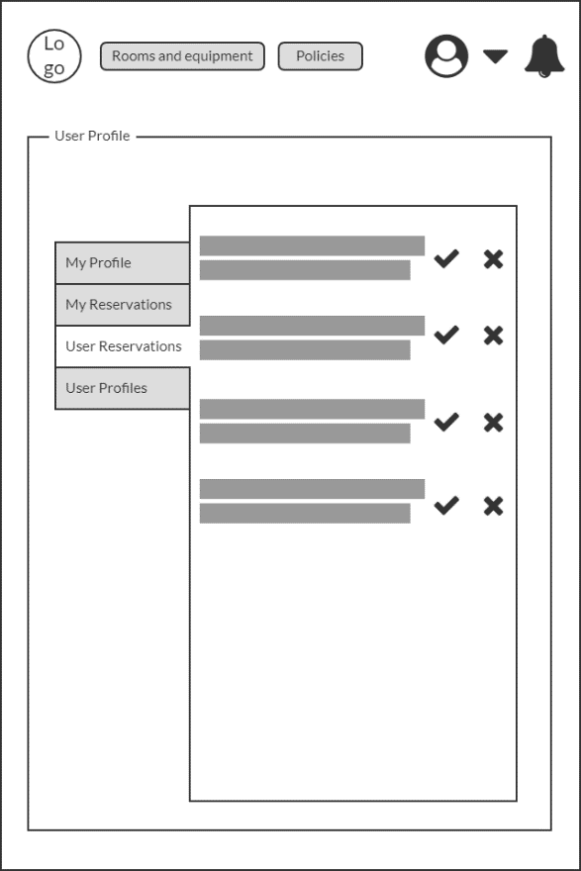 Admin – User registration User Reservation

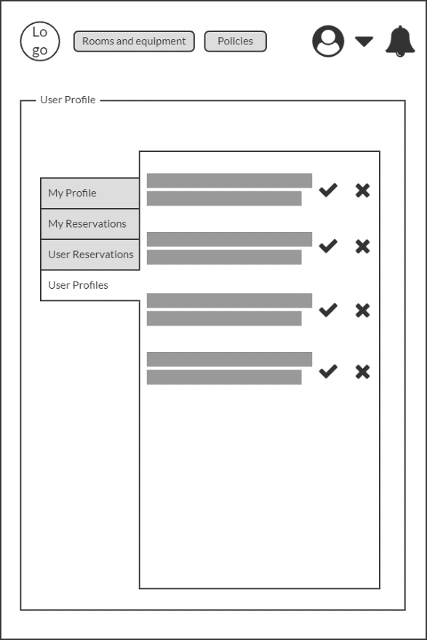

Monitoring page

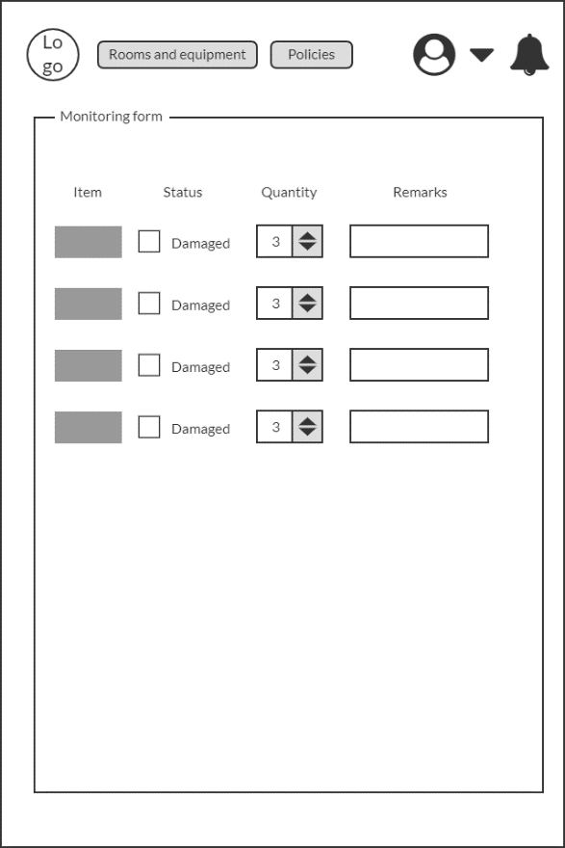

Sequence Diagram

